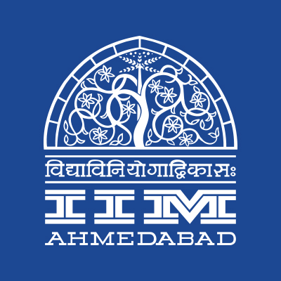

Press Release

**“Hindi Fortnight” celebrated at IIMA**

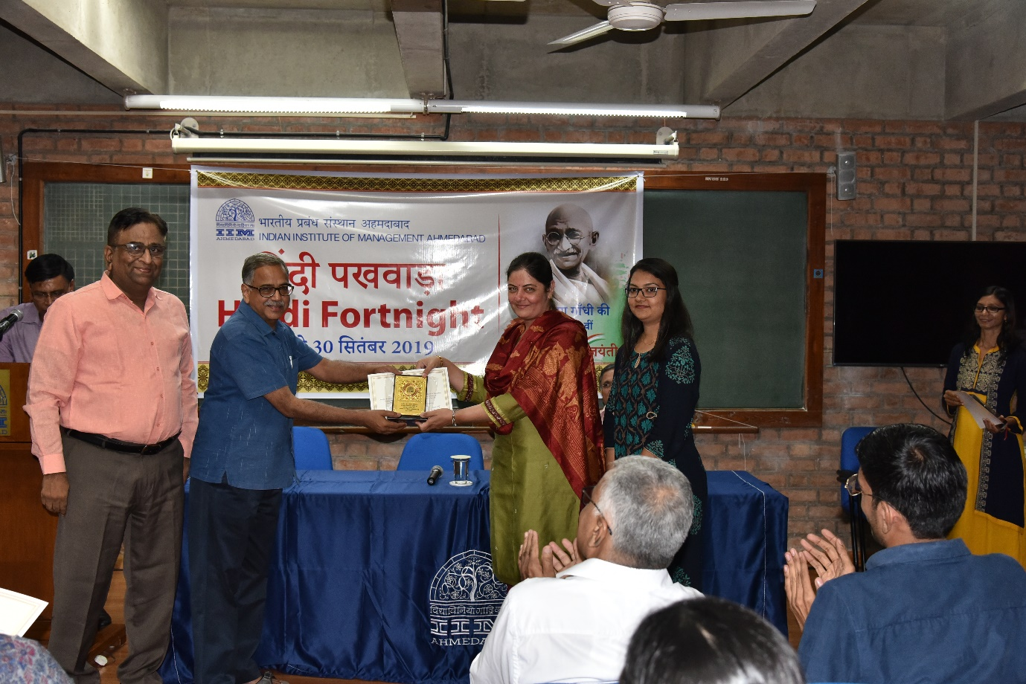

**Felicitation of the winners by Prof. Rakesh Basant, Dean - A&ER, IIMA**

**Ahmedabad | September 30, 2019:** Hindi Fortnight Celebration began on the 16th of September 2019 and lasted until the 30th of September 2019 at the Indian Institute of Management Ahmedabad. Propagation and promotion of our Official Language have been conducted with various competitions such as Hindi Poetry recitation, Hindi Online General Knowledge, Hindi essay writing, Hindi word knowledge contest, Hindi calligraphy, Hindi Extempore, and Hindi Antakshari contest.

The celebratory event began with self-written poetry which saw an overwhelming response from all the members of the Institute. Apart from this, an exhibition of Hindi books was also organized at the Vikram Sarabhai Library of the institute on 24 September 2019, with a view to increasing the interest of readers towards Hindi books.

The winners, who were victorious in all the competitions held during this period, were awarded cash prizes and certificates in accordance with the guidelines of the Ministry of Human Resource Development by Professor Rakesh Basant, Dean (Alumni and External Relations) of the institute. Indian Institute of Management Ahmedabad has always been committed to promoting the propagation of the Official Language Hindi and as per the guidelines of the Ministry of Human Resource Development will continueits efforts even further. Official Language Implementation Committee of the Institute has awarded Shields and Citation to the Outstanding performers for the year 2018-19 of Official language implementation departments of the institute such as Accounts Department, Stores & Purchase Department and Maintenance Department.

-The End-

**About Indian Institute of Management Ahmedabad (IIMA)**

Established in 1961, the Indian Institute of Management, Ahmedabad (IIMA) is recognized globally for excellence in management education. One of the top management schools in the world, IIMA educates leaders of the enterprises. The Institute’s strategic priorities include: strengthening connection with its various constituencies, including academics, practitioners, alumni, and the community; nurturing a high-performance work environment of stretch, autonomy, and teamwork; and strategic growth while maintaining emphasis on quality.

The flagship Post Graduate Programme (PGP) is ranked 21st in the Financial Times Masters in Management Ranking 2017. As per the Financial Times’ Global MBA Ranking 2017, IIMA’s Post Graduate Programme for Executives (PGPX) is ranked 29th in the World. The postgraduate program in food and Agri-Business (PGP-FABM) is ranked 1st in the Eduniversal Masters Ranking 2019. IIMA has been ranked as #1 Management institute as per the National Institutional Ranking Framework (NIRF) rankings of Ministry of Human Resource Development, Government of India.

*For media queries, please contact:*

**Deepak Bhatt, Manager, Communication**

Ph: (Cell) +91-9426229429, (O) +91-79-66324683, Email: [mngr-comm@iima.ac.in](mailto:mngr-comm@iima.ac.in)

**Mitaaly Naidu, Executive, Public Relations**

Ph: (Cell) +91-7069074816, (O) +91-79-66324684, Email: [pr@iima.ac.in](mailto:pr@iima.ac.in)