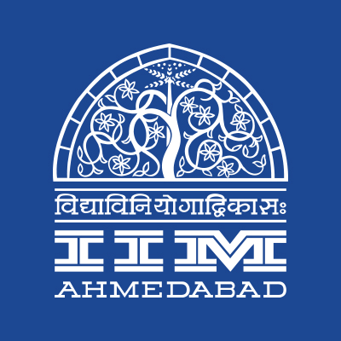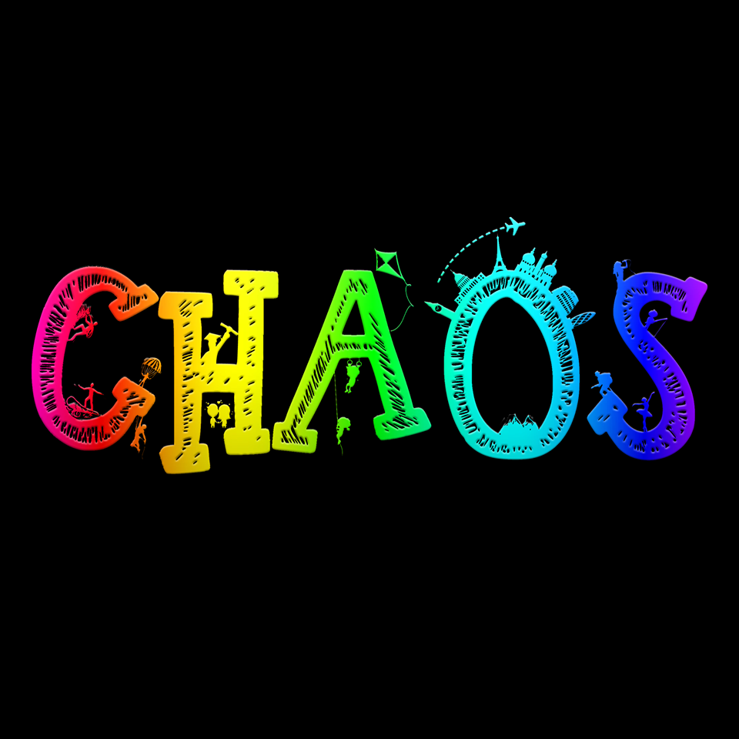

**PRESS RELEASE**

**Chaos starts off with a bang!**

**January 26, 2018 | Ahmedabad**

The annual cultural extravaganza of the Indian Institute of Management Ahmedabad (IIMA), Chaos 2018, kicked off on Thursday, with the theme of “The colors of life.” It started off with a simple inauguration ceremony in the heritage campus which was attended by the Chaos core team and children from IIMA’s Prayaas initiative.

This year the students of the organizing team headed by Ankush Pumba added another dimension to this mega-cultural extravaganza by adding a significant social dimension. For this, the fest has partnered with groups including CRY, HeyHi, SSIU and IIMA’s very own Prayaas and Equal Opportunities Student Committee. As a part of the inauguration, children from Prayaas lit the ceremonial lamp to mark the beginning of the event.

The main attraction of the four-day event, the musical performances or the pro-nites kicked off with a lively performance from Agnee, an Indian Rock band based in Pune with performances from Shirley Satia, Benny Dayal and Salim Sulaiman scheduled over the Republic Day weekend.

The campus also hosted FBB’s Campus Princess Pageant in association with Miss India Organization and was judged by Roshmitha Harimurthy, Miss Diva India Universe 2016. The winner of the pageant was Priya Kansagra who will have an opportunity to participate in the Miss India Finals.

The other events included a marketing workshop titled ‘Brands to Stands’ conducted by Lowe Lintas, a noted advertising agency credited with India’s first TV commercial and popular campaigns for brands including Surf. Another inspiring event on day one witnessed RJ Thvanit from Radio Mirchi took the audience on a humorous journey around FM radio and his own experiences. The Gujarati RJ, who has over 13 years on radio behind him, detailed some of his most successful campaigns and moments.

Republic Day at IIMA was welcomed with a cycling event in association with Chaos and IIMA’s student cycling club. A total of 45 people took part in this event which included participants from PGP, PGPX, FPM, & AFP students, as well as some faculty members with their families. The enthusiastic cyclists started off in the early hours of dawn from the heritage campus and rode to Sabarmati riverfront in time to catch the sunrise. The trail of cyclists was accompanied by a support and recovery vehicle provided by Mybyk to encourage even first-time riders to participate.

For more information, please visit <https://www.facebook.com/IIMA.Chaos/>.

**Quotes from Day 1:**

*"Chaos is an arena for the best in the country to display their talents. At the end of the day, we just hope that all participants have a great time and enjoy themselves.”*

-Ankush Pumba, Secretary, Chaos 2018

“*Our goal is to promote cycling and develop cycling opportunities in a socially and environmentally responsible manner for the benefit of all IIMA community members, and we hope to organize more such events in the future catering to riders of all levels and abilities.”*

- Sandeep Mahalwar, Armed Forces Program’s student on the Cycling Event

**-End of Text-**

|  |
| --- |
| **News in Brief**  The annual cultural extravaganza of the Indian Institute of Management-Ahmedabad (IIM-A), Chaos-2017, kicked off on Thursday, with the theme of “The colors of life”. The main attraction from Day-1 was a lively performance from Agnee, an Indian Rock band based in Pune. The other events included a marketing workshop titled ‘Brands to Stands’ and a workshop on FM by RJ Thvanit. There was also an event for enthusiastic cyclists on the early hours of Republic Day which had them cycling from the heritage campus till the Sabarmati riverfront. |

**About Indian Institute of Management Ahmedabad (IIMA)**

Established in 1961, the Indian Institute of Management, Ahmedabad (IIMA) is recognized globally for excellence in management education. One of the top management schools in the world, IIMA educates leaders of the enterprises. The Institute’s strategic priorities include: strengthening connection with its various constituencies, including academics, practitioners, alumni, and the community; nurturing a high performance work environment of stretch, autonomy, and teamwork; and strategic growth while maintaining emphasis on quality.

As per the latest ranking by The Economist, IIMA is No. 1 School in the world on the parameter of opening up new career opportunities for students. The flagship Post Graduate Programme (PGP) is ranked 16th in the Financial Times Masters in Management Ranking 2016. As per the Financial Times’ Global MBA Ranking 2016, IIMA’s Post Graduate Programme for Executives (PGPX) is ranked 24th in the World. IIMA has been ranked as #1 Management institute as per the National Institutional Ranking Framework (NIRF) rankings of Ministry of Human Resource Development, Government of India.

For media queries, please contact:

|  |  |
| --- | --- |
| Mithila Hegde  Member, Media Cell (PGP-1)  Indian Institute of Management Ahmedabad  Ph: (Cell) +91-9740499011  Email: p17mithilah@iima.ac.in | Aashish Gupta  Marketing & PR Cell, Chaos (PGP-2)  Indian Institute of Management Ahmedabad  Ph: (Cell) +91-8090026763  Email: p16aashishg@iima.ac.in |