

**PRESS RELEASE**

**‘A Day At IIMA': Join us to experience the student life at a top B-school**

## Prayaas, the social initiative of Indian Institute of Management (IIM) Ahmedabad, hosts the 10th edition of its annual flagship event, 'A Day at IIMA' on November 7, 2020.

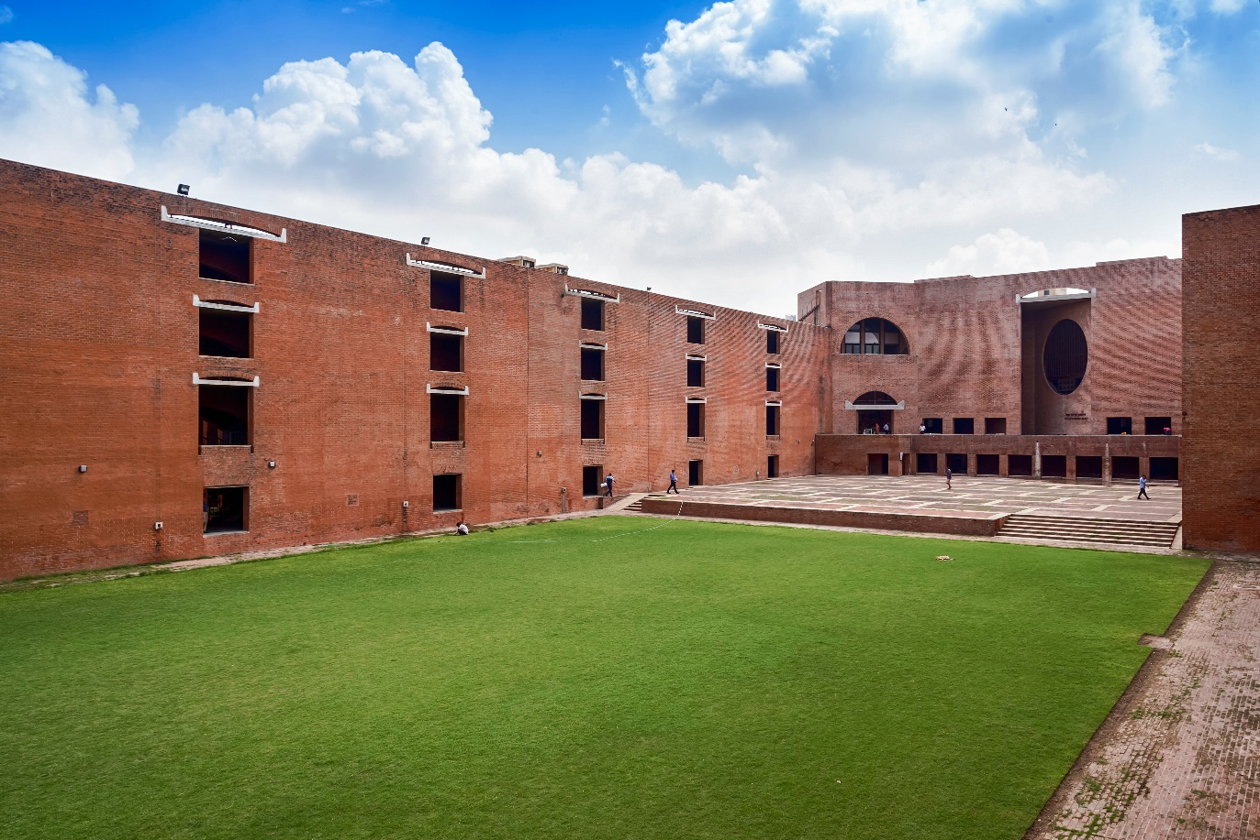

Louis Kahn Plaza, IIM Ahmedabad

**November 03, 2020 | Ahmedabad**

Prayaas, the social initiative of Indian Institute of Management (IIM) Ahmedabad, plans to successfully host the 10th edition of its annual flagship event, 'A Day at IIMA' on November 7, 2020 in a virtual avatar this time. This unique initiative provides an opportunity to the participants to experience the life at the premier B-School at a mere price of Rs.1800. The proceeds from this event are directed towards the education of the underprivileged kids associated with Prayaas.

Participants of 'A Day at IIMA' will be taken through a day in the life of a first-year student of IIMA's flagship MBA Programme.

The day constitutes lectures from renowned Professors from various domains including real-life case discussions to acquaint the participants with the case pedagogy used at the Institute, along with a virtual tour of the hallowed red brick walls.

Started in 2011, the event saw a footfall of around 180 participants last year. Even this year, the programme will accommodate over 180 participants who will be selected on a first come first serve basis.

Prayaas is a social initiative of IIMA responsible for the education of 80+ students from the underprivileged section of the society. Catering to the school tuition fees, cost of the tutors and essential stationary items, the initiative is run completely on voluntary donations from the society. Students as well as anyone who is willing gets an opportunity to contribute to the success of this initiative.

The registrations are open, and the early bird offers, and bulk deals are available now.

You can register for the event at <https://cutt.ly/a-day-at-iima>

For more info, please visit our Social media handles:

<https://www.instagram.com/prayaas_iima/> | <https://www.facebook.com/PrayaasIIMA/>

**About IIMA:**

Indian Institute of Management Ahmedabad (IIMA) is a premier B-school in the Asia Pacific region. Globally, the Institute's programmes have earned high reputation and acclaim, becoming the first Indian institution to receive international accreditation EQUIS. Founded in 1961 as a unique public-private partnership for development through the application of knowledge, today it has overseas presence in Dubai and associates with over 80 foreign B-schools to offer academically superior, market-driven and socially impactful programmes, research and consultancy services. In 2018, IIMA made it to the number four position in the Financial Times (FT) Asia Pacific Top 25 Business School Rank, ahead of all Indian B-Schools. FT conducted the ranking after considering the quality and breath of all the B-schools programmes. Over the last several years, IIMA is the only Indian B-school to feature in the reputed Economist ranking and emerged at number one position in India Ranking 2020 NIRF (National Institutional Ranking Framework), released by the Ministry of Human Resource Development, Government of India.

Over the years, IIMA has benefited more than 38,000 alumni who graduated from its various programmes. Currently, besides its renowned flagship Two-year Master in Business Administration (MBA), earlier known as Post Graduate Programme in Management (PGP); the Institute continues to draw top-quality students to its PhD Programme in Management, MBA in Food and Agri-Business Management (FABM), MBA-PGPX (One-Year Full-Time Post Graduate Programme in Management for Executives), Faculty Development Programme (FDP), Armed Forces Programme (AFP), e-Post Graduate Programme (ePGP), e-Post Graduate Diploma in Advanced Business Analytics (ePGD-ABA), and benefits industry professionals through its short duration Executive Education Programmes.

**For media queries, please contact:**

|  |  |
| --- | --- |
| Amjad Rasheed  Prayaas Coordinator (PGP-2)  Indian Institute of Management, Ahmedabad  Ph: (Cell) +91-8891739575  Email: p19amjad@iima.ac.in | Goldy Admane  Media Secretary (PGP-2)  Indian Institute of Management, Ahmedabad  Ph: (Cell) +91-7758962987  Email: p19goldy@iima.ac.in |