

Press Release

IIMA hosts ‘iDEX: Innovation for Defence Excellence’ Seminar
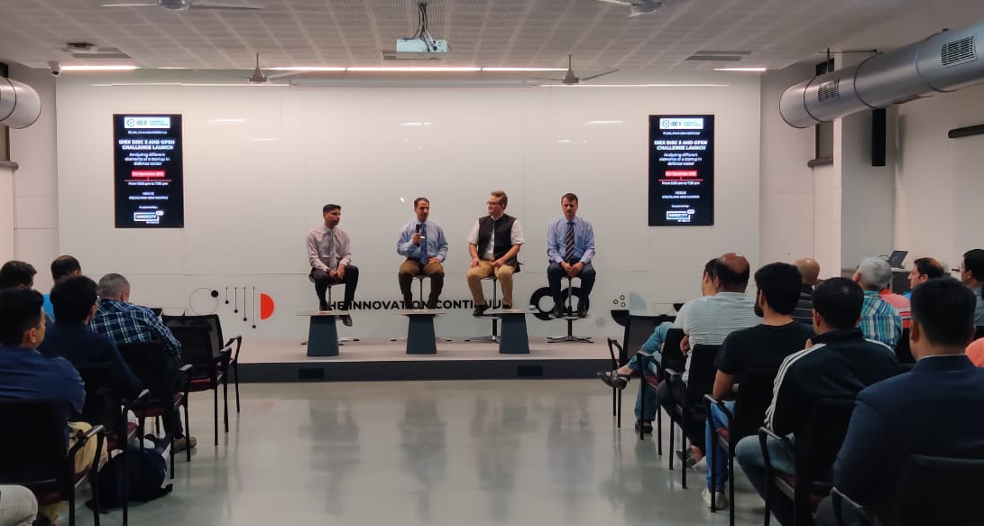
Dr V K Rai, Chairman, iDEX spoke to the IIMA students class

December 11, 2019| Ahmedabad
In an effort to scale up and give a boost to the defence start-ups, a seminar on ‘iDEX: Innovation for Defence Excellence’ followed by a panel discussion was held at Centre for Innovation, Incubation and Entrepreneurship (CIIE.CO) at IIMA. CIIE.CO is the Incubation hub at IIMA, which is one of India’s leading centres catalysing the entrepreneurship ecosystem in the country through its various interventions and initiative. The seminar was attended by the Chairman, iDEX, Dr V K Rai; Start-up mentor, Mr Ravin Vyas; Wing Cdr Puneet Chadha, Defence PRO (Gujarat), Members of CIIE.CO, members of the IIMA community and other senior dignitaries from the Armed Forces. Various speakers delivered a series of lectures ‘iDEX’ to the students of the Armed Forces Programme (AFP) at IIMA.
Armed Forces Programme (AFP) represent a group of professionals who embrace change, as they leave the comforts of careers in the armed forces to take on challenges of the corporate world. Indian Institute of Management Ahmedabad partners in this change process by arming the 60 selected AFP participants, with the knowledge and skills required to fight a corporate battle, through this intense six months’ residential programme. These officers come with vast leadership experience and a variety of skills which are keenly sought after by the corporate sector.
In his talk, Dr V K Rai emphasized on the vital need for promoting indigenous capability in the defence sector and outlined the scope of the Innovation for Defence Excellence (iDEX) project initiated under the aegis of Atal Innovation Mission (AIM). He also highlighted the establishment of Defence Innovation Fund (DIF) aimed to create an ecosystem to foster innovation and technology development in Defence by engaging the industry, MSMEs, start-ups, individual innovators, R&D institutions and the academia.

Dr. V. K. Rai spoke about provision of providing necessary assistance in terms of grants/funding and technical support to enable the development of technologies with the potential for adoption by Indian defence sector. He also spelt out the core objectives of the Defence Innovation Fund as facilitation of rapid development of new, indigenous, and innovative technologies and creation of a culture of engagement with innovative start-ups, to encourage co-innovation and co-creation for defence sector.
iDEX has invited interested IIMA AFP students to join them and to contribute to the to the success of this noble governmental initiative.
- End of Text

About Indian Institute of Management Ahmedabad (IIMA)

Established in 1961, the Indian Institute of Management, Ahmedabad (IIMA) is recognized globally for excellence in management education. One of the top management schools in the world, IIMA educates leaders of the enterprises. The Institute’s strategic priorities include: strengthening connection with its various constituencies, including academics, practitioners, alumni, and the community; nurturing a high performance work environment of stretch, autonomy, and teamwork; and strategic growth while maintaining emphasis on quality.
The flagship Post Graduate Programme (PGP-MBA) is ranked 19th in the Financial Times Masters in Management Ranking 2018. As per the Financial Times’ Global MBA Ranking 2016, IIMA’s Post Graduate Programme for Executives (PGPX-MBA) is ranked 31st in the World. IIMA has been ranked as #1 Management Institute as per the National Institutional Ranking Framework (NIRF) rankings of Ministry of Human Resource Development, Government of India in 2018. Over the years, the Post Graduate Programme in Food and Agri-business Management (PGP-FABM) of IIMA has been ranked number one globally in its category in the Eduniversal Best Masters’ Ranking in Agribusiness/Food Industry Management.
IIMA features at the top position in the India Ranking 2018 (National Institutional Ranking Framework) released by the Ministry of Human Resource Development (MHRD), Government of India.

For media queries, please contact:

Deepak Bhatt
Manager, Communication
Ph: (Cell) +91-9426229429, (O) +91-79-71524683
Email: mngr-comm@iima.ac.in

Mitaaly Naidu
Executive, Public Relations
Ph: (Cell) +91-7069074816, (O) +91-79-71524684
Email: pr@iima.ac.in

