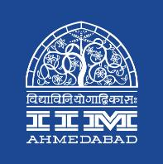

Press Release

Indian Family Business Conference 2018 at IIMA

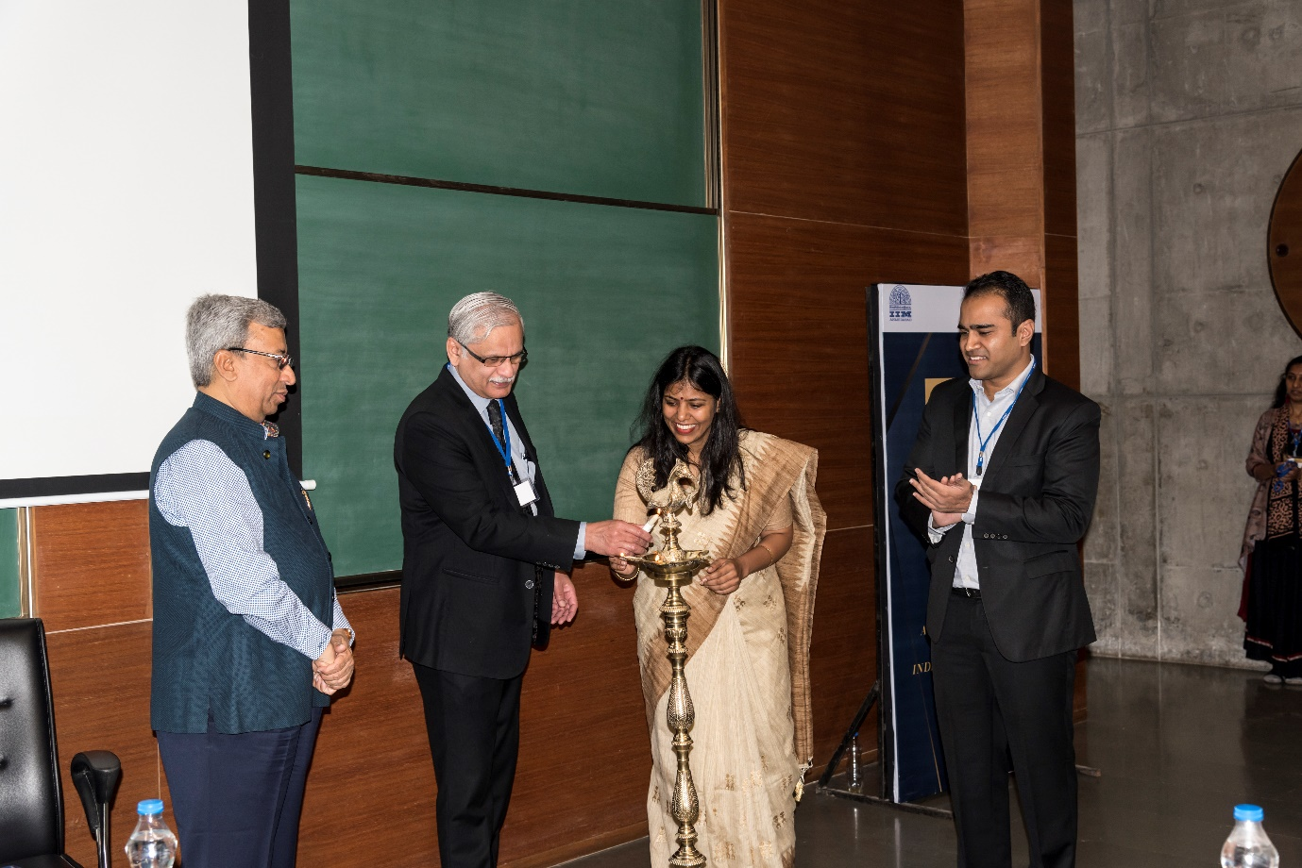

Lighting of the lamp by (l-r) Pankaj Patel, Chairperson, Cadila Healthcare; Prof. Errol D’Souza, Director, IIMA; Prof. Chitra Singla, Faculty Chair, IFBC 2018 & Aditya Gadge, Founder, Priwexus

**December 6, 2018 | Ahmedabad**

Indian Family Business Conference 2018 (IFBC) was held at IIMA on Dec 3-4, 2018 in partnership with Priwexus. At the inauguration, Prof. Errol D’Souza, Director, IIMA said, *“The conference is a mechanism to enhance the opportunities for family businesses and academia to collaborate and enhance the understanding and practice of family business. The conference focuses on family wealth management objectives, the governance of the business, segregation of business from private assets, risk management and succession planning, and record keeping and maintenance. Above all, since it is a realm where confidentiality is crucial it provides an opportunity for all to share information with the security that it will not be misused and that it will benefit all who participated in the first of its kind event.”*

Prof. Chitra Singla, Faculty Chair of IFBC 2018 added, *“This platform is created with two purposes in mind: First, it should allow exchange of information and knowledge between big business houses and SMEs. Second, it should act as a bridge between the academic world and the practitioners’ world and allow opportunities for creation and dissemination of knowledge that would be relevant for Indian Family Businesses.”*

Aditya Gadge, founder of Priwexus, also talked about how Indian family businesses sustain over multiple generations and aim of the conference is to bring family in sync with the business.

The first day of the conference started with a key-note speech by IIMA’s board member- Mr. Pankaj Patel, who is also the Chairperson of Cadila Healthcare. He talked about how culture and its continuance is one of the most important aspect for survival of any family business. Giving example of his firm, he said that family businesses should try to focus on meritocracy and avoid supporting extended family by bringing them in your firm. This point was also emphasized by Mr. Aditya Aggarwal and Mr. Manish Goenka, Directors of Emami group, who spoke about the importance of inculcating family values among younger generations for long term sustenance of the family business. They also shared that its crucial to hire professional managers on the basis of values as well as skill sets; having common values would allow goal alignment among the promoters and the professional CEOs.

In addition to nurturing value system, success of family business is dependent upon the execution capability of the management, as shared by Mr. Satya Narayan Bansal-CEO Barclays, India. The conference also had sessions on benefits of having family council, family constitution and family offices and how these formal structures help in managing conflict as well as allocating wealth among family members. However, if the social fabric or bond of the family is weak or broken then these formal structures will not be very effective mechanisms to resolve issues as shared by Mr. Rahul Kanodi, Vice-Chairman and CEO, Datamatics. Mr. Sanjay Mariwala, MD OmniActive Health Technologies and Mr. Kanodia also highlighted the importance of communication among family members and the need to be sensitive to interpersonal dynamics of family members.

The second day of the conference started with a talk from Dr. Arokiaswamy Velumani, Chairman of Thyrocare who emphasized on developing abilities to differentiate and take risky decisions. Mr. Abhishek Lodha, MD and CEO of Lodha Group, provided his perspective on how family and business are two separate entities and why these two entities should be run by different heads. Mr. Ameet Gupta, Director Havells, talked about ‘Entrepreneurship with guts’ and shared stories of Sylvania and Llyod acquisitions by Havells. The conference ended on an insightful note from Mr. Ashank Desai, IIMA’s board member and founder of Mastek Ltd., who talked about traits that leaders of family businesses must have to do business in a VUCA (volatile, uncertain, complex, and ambiguous) world. He advised younger generation of family businesses to develop ability to learn various new and relevant skills and unlearn obsolete skills.

-End of Text-

*Established in 1961, the Indian Institute of Management, Ahmedabad (IIMA) is recognized globally for excellence in management education. One of the top management schools in the world, IIMA educates leaders of the enterprises. The Institute’s strategic priorities include: strengthening connection with its various constituencies, including academics, practitioners, alumni, and the community; nurturing a high- performance work environment of stretch, autonomy, and teamwork; and strategic growth while maintaining emphasis on quality.*

*The flagship Post Graduate Programme (PGP) is ranked 21st in the Financial Times Masters in Management Ranking 2017. As per the Financial Times’ Global MBA Ranking 2017, IIMA’s Post Graduate Programme for Executives (PGPX) is ranked 29th in the World. The postgraduate program in food and Agri Business (PGP-FABM) is ranked 1st in the Eduniversal Masters Ranking 2018. IIMA has been ranked as #1 Management institute as per the National Institutional Ranking Framework (NIRF) rankings of Ministry of Human Resource Development, Government of India.*

**For media queries, please contact:**

Deepak Bhatt

Manager, Communications

Ph: (Cell) +91-9426229429, (O) +91-79-66324683

Email: [mngr-comm@iima.ac.in](mailto:mngr-comm@iima.ac.in)

Mitaaly Naidu

Executive, Public Relations

Ph: (Cell) +91-7069074816, (O) +91-79-66324684

Email: [pr@iima.ac.in](mailto:pr@iima.ac.in)