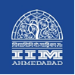

**Press Release**

**The 3rd International Conference on**

**Advances in Healthcare Management Services (ICAHMS) 2017 concluded at IIMA**

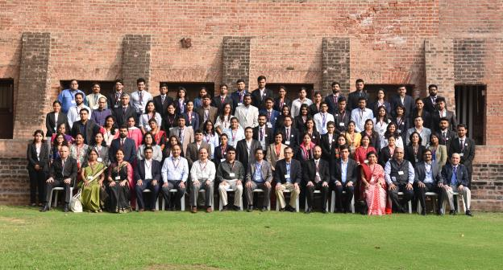

**Caption: ICAHMS 2017 participants with IIMA faculty members.**

**December 13, 2017 | Ahmedabad**

The Centre for Management of Health Services (CMHS) at in the Indian Institute of Management Ahmedabad (IIMA) organized the 3rd IIMA International Conference on Advances in Healthcare Management Services (ICAHMS) during December 9-10, 2017 at IIMA.

The conference witnessed insightful keynote addresses presented by renowned delegates include Dr. **Surinder Singh,** National Institute of Biologicals; Dr. A K Mukherjee, Indian Spinal Injuries Centre; Dr. Prabhakar Chebiyyam, Atul Limited; Dr. Anoop Daga, AIIMS, Delhi; Dr. Ravi Gaur, Oncquest; Dr. Rohan Desai, Plexusmd; Prof. Piyush Kumar Sinha, IIM, Ahmedabad and Dr. Phalakshi Manjrekar, Hinduja Hospital. These series of lectures covered a broad range of topics including Development of Bio Therapeutics, Injury Burden, Healthcare management education and Patient Safety.

Academic workshops on Managing Healthcare Professionals and Meta-Analysis in Healthcare Research were also organized. These interactive sessions allowed the participants to broaden their interests and knowledge in different aspects of healthcare management.

In addition to the keynote lectures, Panel Discussions on Policies for Resurgent Indian Healthcare Sector and Transforming Indian Healthcare through Innovation were also organized. The panelists were Sucheta Banerjee Kurundkar, Clinical Development Services Agency, S. Eswara Reddy, CDSCO, S.K.Nanda, Gujarat State Fertilizers & Chemicals Limited, Praween Agrawal, United Nations Children’s Fund, Shirshendu Mukherjee, Biotechnology Industry Research Assistance Council Bill and Melinda Gates Foundation, Gagandeep Kang, Translational Health Science & Technology Institute, DBT, Anoop P Ambika, Genpro Life Sciences India Pvt. Ltd.

Presentations on various topics such as healthcare in human resource management, marketing services in healthcare, data analysis management in healthcare, medical tourism, etc. were made by the participants.

The participants of the conference were an interesting mixture of healthcare management researchers and experienced healthcare professionals and yet all felt the conference was a great learning experience for all of them. The conference delegates also agreed on the fact that there is a big need for healthcare management professionals in the country. They also felt that this conference is a platform where ideas and knowledge have been shared, exchanged and taken to move forward. Overall, it was a successful conference of two days full of learning.

- End of Text-

**About Indian Institute of Management Ahmedabad (IIMA)**

Established in 1961, the Indian Institute of Management, Ahmedabad (IIMA) is recognized globally for excellence in management education. One of the top management schools in the world, IIMA educates leaders of the enterprises.The Institute’s strategic priorities include: strengthening connection with its various constituencies, including academics, practitioners, alumni, and the community; nurturing a high performance work environment of stretch, autonomy, and teamwork; and strategic growth while maintaining emphasis on quality.

As per the latest ranking by *The Economist*, IIMA is No. 1 School in the world on the parameter of opening up new career opportunities for students. The flagship Post Graduate Programme (PGP) is ranked 16th in the *Financial Times* Masters in Management Ranking 2016. As per the *Financial Times’* Global MBA Ranking 2016, IIMA’s Post Graduate Programme for Executives (PGPX) is ranked 24th in the World. IIMA has been ranked as #1 Management institute as per the National Institutional Ranking Framework (NIRF) rankings of Ministry of Human Resource Development, Government of India.

**IIMA MEDIA CONTACTS**

|  |  |
| --- | --- |
| **Mr. Deepak Bhatt**  Manager, Communications  Email: [mngr-comm@iima.ac.in](mailto:mngr-comm@iima.ac.in) Phone: +91-79-66324683 | **Ms. Mitaaly Naidu**  PR Executive, Communications  Email: [pr@iima.ac.in](mailto:pr@iima.ac.in) Phone: +91-79-66324684 |