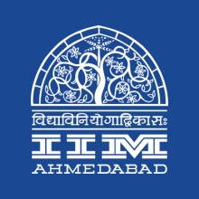

**PRESS RELEASE**

**IIMA HR Leadership Conclave Series 2018 takes over Hyderabad**

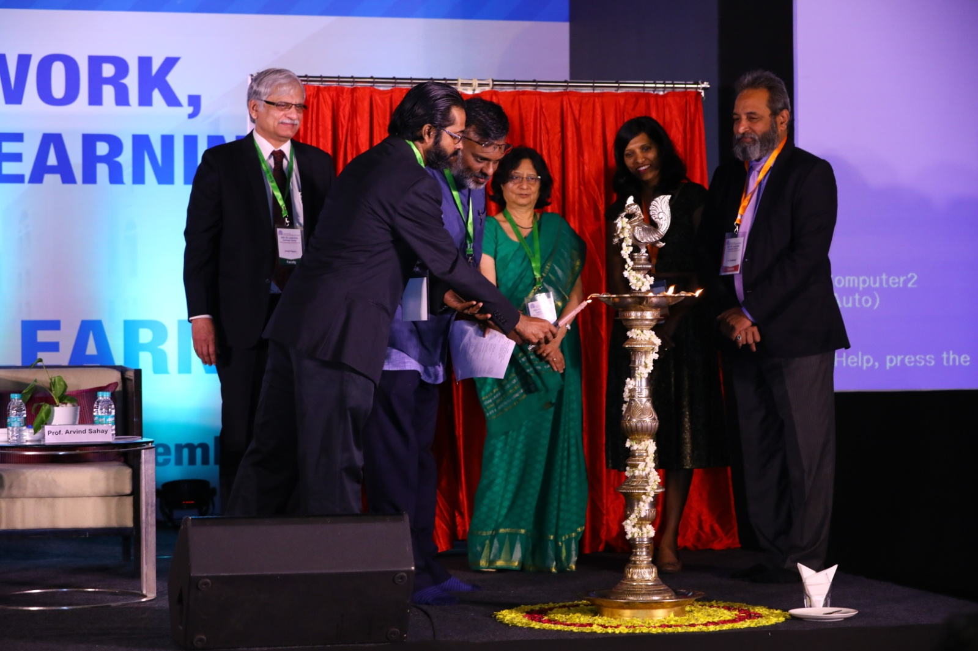

Lighting of the lamp (L-R) Prof. Arvind Sahay, Chairperson, EEP, IIMA; Prof. Errol D’Souza, Director, IIMA; Prof. Biju Varkkey, Faculty Chair, IIMA HR Leadership Conclave 2018; Prof. Rekha Jain, Executive Chair, IITCOE, IIMA; a participant and Mr. K. Padmakar, Director – Human Resources, Bharat Petroleum Corporation Limited

**Hyderabad ∣ September 7, 2018:** IIMA organized the third edition of its HR Leadership Conclave on ‘The Future of Work, Workforce and Learning’ today at The Westin Hyderabad Mindspace, Hyderabad. The theme of this year’s conclave was “Disruptions & Learning”.

Eminent panellists shared their expert opinion on two topics: “Building a Design Thinking Culture in Organizations” and Leadership Development for Successful Digital Transformations”. *Mr. K. Padmakar, Director – Human Resources, Bharat Petroleum Corporation Limited, a panellist, shared thoughts about the conclave, “Conclaves of industry academia interface are critical in enlightening all minds. Towards this extent this conclave was very enlightening and has given me a lot to mull over.”*

*Prof. Biju Varkkey, Faculty Chair of IIMA HR Leadership Conclave elaborated on, “The conclave focused on the emerging and latest practices in Learning and Development function globally and how it can be applied in the organizations. Keeping the fast changing developments globally in mind, IIMA Conclave offered a platform for leaders of various organizations and from Government to discuss and explore options through the lively panel discussions.”*

IIMA proactively connects with Corporate, Government, Alumni and Researchers over forums like HR Leadership Conclaves to discuss the most recent and emerging trends in organizations and management, thus helping organizations to stay competitive and engaging the talent through technology.

*Prof. Errol D’Souza, Director, IIMA went on to speak about the history and evolution of education of business schools and the current challenges for a modern organization. He emphasized on the organizational requirements of 1) Leadership skills, 2) Integrative/Systems thinking and 3) Importance of Communication. He added, “As an Institute of management, IIMA researches on these topics to help organizations to find tangible solutions. Some of these research insights come back as a part of Executive Education Programs.”*

The participants also got insights from the industry leaders on the current practices in the context of Learning and Development. The conference was attended by Senior Level Professionals from HR and other areas in Skill Development, Technology Adoption and Competency Development from various organizations.

**About IIMA Executive Education Program (EEP):**

Setup in 1961 by the Govt. of India and the Govt. of Gujarat state in a true spirit of ‘Public-Private Partnership’, IIMA have had started off with Executive Education wing in 1961 which was followed by its flagship programme “PGP” in 1964. IIMA has been consistently ranked as the premier management school in the country by several national agencies. IIMA has also been acknowledged internationally by a renowned international association named EFMD (European Foundation for Management Development).

*“Executive Education is part of IIMA’s DNA. We distinguish ourselves from the other management schools as at EEP, we focus on “actionable learning” - Actionable learning is based on research with real action which helps organizations develop creative, flexible and successful strategies to pressing problems.” said Prof. Arvind Sahay, Chairperson, EEP, IIMA.*

Organizations in this ever-changing world strive to update the knowledge and skills of its executives for coping with the increasing competition through popularly known as Management Development Programme or nowadays known as Executive Education in sharpening their management leadership skills through discussions, group exercises, simulations, networking events etc which aid cross-fertilisation and innovation.

IIMA’s Executive Education is a major activity through which it has been designing and conducting open enrolment and customised programs for Governments, Corporates, Multi-national companies and parastatals like regulatory bodies, on a wide variety of topics including policy issues.

* The End –

**For media queries, please contact: Mr. Deepak Bhatt**

Manager, Communications

Ph: (Cell) +91-9426229429, (O) +91-79-66324683

Email: [mngr-comm@iima.ac.in](mailto:mngr-comm@iima.ac.in)

**Ms. Mitaaly Naidu**

Executive, Public Relations

Ph: (Cell) +91-7069074816, (O) +91-79-66324684

Email: [pr@iima.ac.in](mailto:pr@iima.ac.in)