



PRESS RELEASE
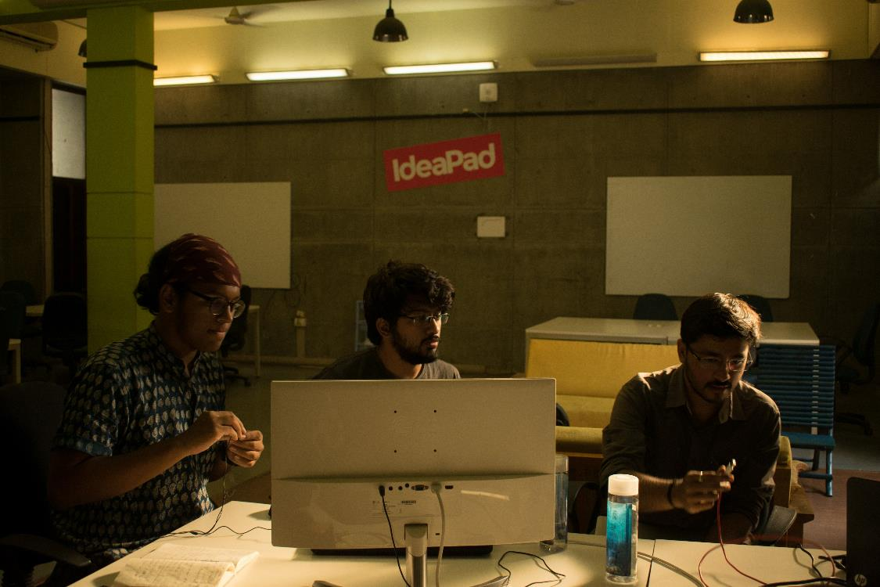
IIMA students form a Management Clinic for Startups & SMEs

A startup’s operations in full throttle at CIIE, IIMA Startup incubator
October 30, 2017 | Ahmedabad
The Entrepreneurship club of Indian Institute of Management Ahmedabad, Entre is launching a Management Clinic aimed at helping the Startups and Small & Medium Enterprises (SMEs) effectively, to address their needs, plan for growth and to ensure the perpetuity of their business. The advisory services will be offered at a nominal cost by students of IIMA who will be guided by faculty members acting as Advisors for the student teams.
The program is structured to facilitate IIMA students to engage with selected firms for a period of up to 4 weeks to guide them on how to solve their most vexing problems. The businesses will find a collaborative environment where students would help them diagnose and structure the method of addressing challenges they face. This service will be provided at a nominal registration fee of INR 3000 payable at the start of the engagement.
Gourav Beriwal, Member of Organizing Team for the initiative, while talking about the motivation behind the program said, “Management Clinic is serving two needs at the same time: demonstrating to students the real-world applications of their studies, and providing SMEs with access to sound management principles and innovative ideas. The idea is streamlined with the Government initiative of Startup India and also in alignment with our goal to build community outreach programs at IIMA and help in Nation building at the grassroots level.”
The pilot phase of the initiative has been successfully concluded where 2 businesses have been supported through this initiative. A soft launch strategy and online marketing campaign were designed for a local SME that was planning to launch an herbal alternative to Tea. Talking about the support he received, the Proprietor of SME commented that “This idea of a Management Clinic is the need of the hour. The recommendation by the team was at par with the IIMA standards. More businesses should benefit from this initiative.”
In yet another pilot, the Management Clinic helped Beany Bunnies, a day-care center create a marketing campaign. Here’s what the founder had to say about the engagement: “The brains behind the management clinic at IIM Ahmedabad have helped my startup by presenting some really logical scenarios and suggestions that will definitely take it to the next level and help it grow much better. Their work on how to manage my limited funds for marketing – both online and offline and what issues to focus on when it comes to branding has been really helpful.”
Prof. Amit Karna, Associate Professor of Strategy at IIMA, one of the advisors for Management Clinic, commented: “Management Clinic is a student initiative aimed at creating a strong platform for the students of IIMA and community at large, to be able to apply management practices learnt in the classroom in real life. We are hoping that interactions through the clinic will benefit the business owners of Ahmedabad with solutions to routine problems and better ways of doing business, at the same time providing real-life exposure to our students.”
Interested Startups/ SMEs may apply by filling a form at https://goo.gl/YWujUa. More info is available at http://www.entrecell.iima.ac.in/events/and the Facebook page of Management Clinic: https://www.facebook.com/managementclinicIIMA.
-End of Text-

News in Brief
Students of Indian Institute of Management Ahmedabad are launching a Management Clinic aimed at helping the Startups and Small & Medium Enterprises (SMEs) effectively address their needs, plan for growth and ensure the perpetuity of their business. The advisory services will be offered at a nominal cost of INR 3000 by students of IIMA who will be guided by faculty members acting as Advisors for the student teams. The program is structured to facilitate IIMA students to engage with selected firms for a period of up to 4 weeks to diagnose problems and structure solutions for the issues the businesses face.

About Indian Institute of Management Ahmedabad (IIMA)
Established in 1961, the Indian Institute of Management, Ahmedabad (IIMA) is recognized globally for excellence in management education. One of the top management schools in the world, IIMA educates leaders of the enterprises.

The Institute’s strategic priorities include: strengthening connection with its various constituencies, including academics, practitioners, alumni, and the community; nurturing a high performance work environment of stretch, autonomy, and teamwork; and strategic growth while maintaining emphasis on quality.

As per the latest ranking by The Economist, IIMA is No. 1 School in the world on the parameter of opening up new career opportunities for students. The flagship Post Graduate Programme (PGP) is ranked 16th in the Financial Times Masters in Management Ranking 2016. As per the Financial Times’ Global MBA Ranking 2016, IIMA’s Post Graduate Programme for Executives (PGPX) is ranked 24th in the World. IIMA has been ranked as #1 Management institute as per the National Institutional Ranking Framework (NIRF) rankings of Ministry of Human Resource Development, Government of India.

For media queries, please contact:
Goutham Senthruvel  Manager, Management Clinic (PGP-2)  Indian Institute of Management Ahmedabad  Ph: (Cell) +91-9003242024  Email: a16gouthams@iima.ac.in | Balaji Uppala  Media Secretary (PGP-2)  Indian Institute of Management Ahmedabad  Ph: (Cell) +91-7042705642  Email: p16srimukhab@iima.ac.in

Name not being revealed due to Non-Disclosure Agreements

