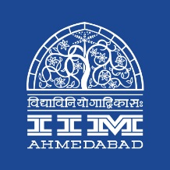

Press Release

**4th International Yoga day was celebrated at IIMA**

**June 21, 2018 | Ahmedabad**

Photograph

To mark the fourth International Yoga day, IIMA organized an evening of ‘Yoga session’ today at KLMDC Conference Hall, IIMA old campus. This annual celebration has always received a warm welcome from IIMA community members with this year’s turn out reaching **____**. Prof. Errol D’souza, Director, IIMA and Prof. Prahalad Venketshan, Chairperson, Sports and Recreational Activities (SARA) committee, IIMA addressed the students, faculty, officers, staff and their family members before the event.

The session is a culmination of a month long Yoga class by Mrs. Geeta Goswamy, Yoga instructor. The entire “Yoga asanas” lasted for an hour and ended at 7.30 p.m. with “Sanskrit Shlokas” and food habit suggestions. After the Yoga session appropriate refreshments were served to all the participants.

* The End -