

**PRESS RELEASE**

**Blood Donation Camp at IIM Ahmedabad**

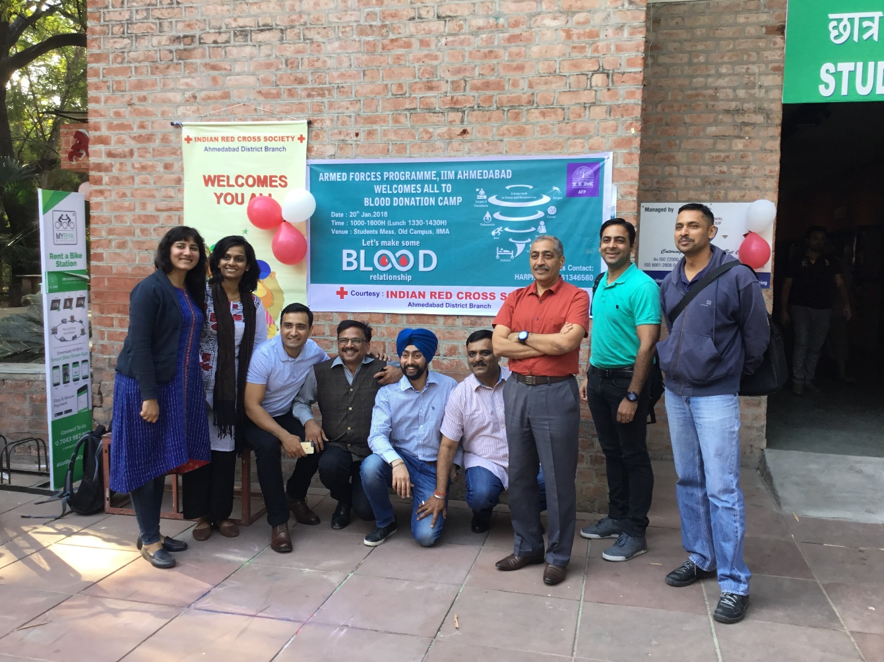

Students of the Armed Forces Programme at IIM Ahmedabad, at the Blood Donation Camp

**January 23, 2018 | Ahmedabad**

Student officers of the Armed Forces Programme (AFP), at Indian Institute of Management Ahmedabad (IIMA), organized a Voluntary Blood Donation Camp inside the Students’ Mess, Old Campus on January 20, 2018. The camp was conducted in association with the Ahmedabad Red Cross Society to spread awareness on the importance of regular blood donation.

204 members of the IIM Ahmedabad community came forward to donate blood, in a six-hour long session, setting a new record among blood donation camps held on the campus.

Wing Commander Ajit Singh and Squadron Leader Dhillon of the Indian Air Forces, members of the organizing team expressed their sincere gratitude to the entire IIM Ahmedabad community for making this event a huge success.

Commenting on the event, Mr. Singh said *“We had started this camp with firm belief that we will organize record breaking blood donations. Someone told us that as per available information, maximum figure of donation at IIM was below 140. So, our target was 175. The enthusiasm shown by IIMA students and staff was the reason that when we were crossing 150-mark, Red Cross had to arrange immediate supplies as they were not ready for this. It was an amazing experience.”*

-End of Text-

|  |
| --- |
| **News in Brief**  Student officers of the Armed Forces Programme (AFP), Indian Institute of Management Ahmedabad (IIMA), organized a Voluntary Blood Donation Camp inside Students’ Mess, Old Campus on 20th January 2018. The camp was conducted in association with the Ahmedabad Red Cross Society to spread awareness on the importance of regular blood donation.  This event witnessed 204 community members of IIM Ahmedabad coming forward to donate blood, in a six-hour long session, setting a new record among blood donation camps held on the campus. |

**About Indian Institute of Management Ahmedabad (IIMA) and Armed forces Programme (AFP)**

Armed Forces Programme is a six months residential course in Business Management held at Indian Institute of Management, Ahmedabad for officers of the Indian Armed Forces, who are making a transition to civil organisations.

Established in 1961, the Indian Institute of Management, Ahmedabad (IIMA) is recognized globally for excellence in management education. One of the top management schools in the world, IIMA educates leaders of the enterprises.The Institute’s strategic priorities include: strengthening connection with its various constituencies, including academics, practitioners, alumni, and the community; nurturing a high performance work environment of stretch, autonomy, and teamwork; and strategic growth while maintaining emphasis on quality.

As per the latest ranking by *The Economist*, IIMA is No. 1 School in the world on the parameter of opening up new career opportunities for students. The flagship Post Graduate Programme (PGP) is ranked 16th in the *Financial Times* Masters in Management Ranking 2016. As per the *Financial Times’* Global MBA Ranking 2016, IIMA’s Post Graduate Programme for Executives (PGPX) is ranked 24th in the World. IIMA has been ranked as #1 Management institute as per the National Institutional Ranking Framework (NIRF) rankings of Ministry of Human Resource Development, Government of India.

For media queries, please contact:

|  |  |
| --- | --- |
| Mithila Hegde  Member, Media Cell (PGP-1)  Indian Institute of Management Ahmedabad  Ph: (Cell) +91-9740499011  Email: p17mithilah@iima.ac.in | Arpit Jain  External Media Relations (PGP-2)  Indian Institute of Management Ahmedabad  Ph: (Cell) +91-9916288168  Email: p16arpitj@iima.ac.in |