

**IIMA’s 13th PGPX Batch Inaugurated**

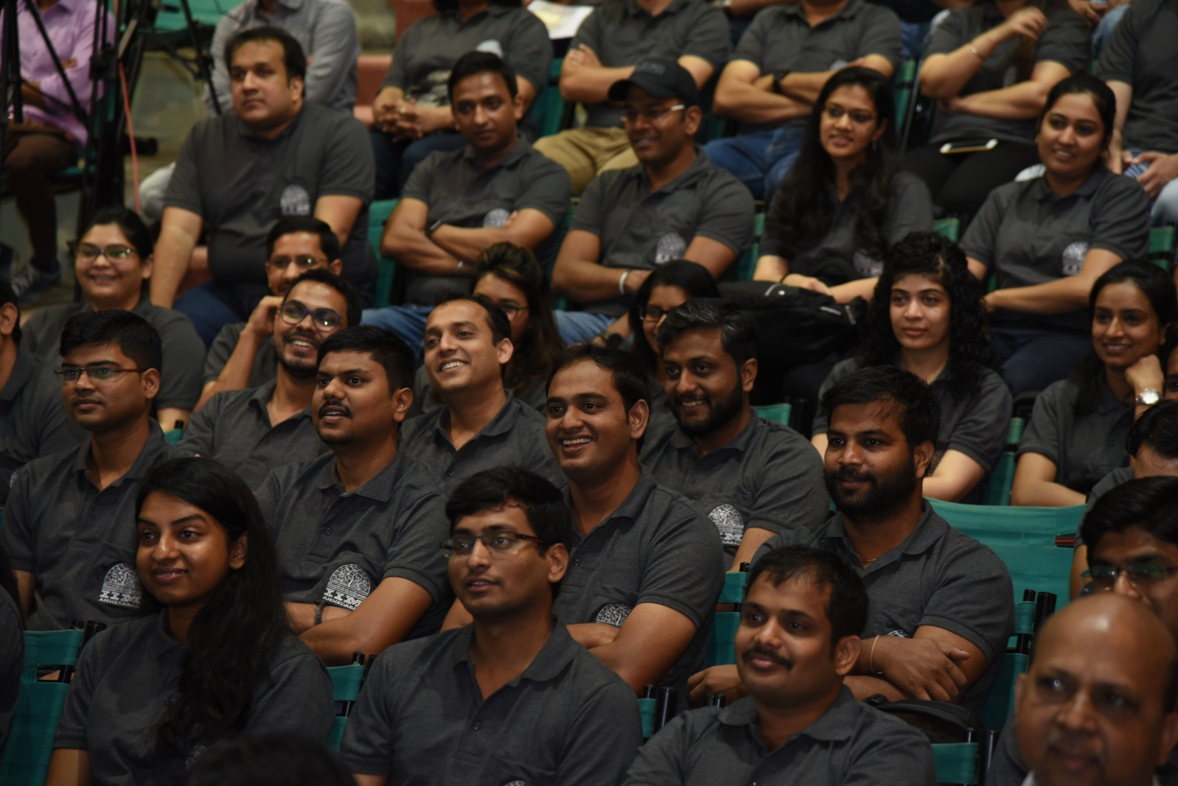

***Caption: PGPX 2018-19 Batch Induction day***

**April 12, 2018 | Ahmedabad**: Thirteenth batch (13th) of the Indian Institute of Management, Ahmedabad (IIMA)’s one year full time residential Post Graduate Programme in Management for Executives (PGPX) for 2018-19 was inaugurated on Thursday, April 12, 2018 by Director, Prof. Errol D’Souza, and welcomed by Prof. Arindam Banerjee, Chairperson, PGPX and Prof. Shailesh Gandhi, Dean- Programme at RJM Auditorium, Indian Institute of Management Ahmedabad (IIMA).

One hundred and thirty eight students have joined the PGPX-XIII batch. The 2018-19 batch has an average GMAT score of around 700 and GRE score of 323, average age of around 32 years, average total work experience of 8.9 years, and average international experience of approximately two years.​ ​

The current batch is also very diverse in terms of work-experience (19 industries, innumerable functional areas, and 115 companies), gender (16.67% of the batch are women), NRIs (17.39% are residing outside India, spread across 11 countries) and international work-experience (54.35% of the batch has worked abroad before joining PGPX).

Launched in 2006, more than 1000 students have graduated from PGPX so far. ​Till 2016-17, the PGPX intake was 90 and last year, the institute added one more section to enhance learning experience of participants. ​With the overwhelming response, we have continued the extra section and accordingly, 138 students have been admitted this year.

​*Professor Arindam Banerjee, Chairperson, PGPX, exhorted the incoming batch to focus on learning. Speaking on the occasion, he said, “Academic rigor and mental discipline would determine success in this program.”*

- The End -

**About IIMA:**

Established in 1961, the Indian Institute of Management, Ahmedabad (IIMA) is recognized globally for excellence in management education. One of the top management schools in the world, IIMA educates leaders of the enterprises.

The Institute’s strategic priorities include: strengthening connection with its various constituencies, including academics, practitioners, alumni, and the community; nurturing a high performance work environment of stretch, autonomy, and teamwork; and strategic growth while maintaining emphasis on quality.

As per the latest ranking by The Economist, IIMA is No. 1 School in the world on the parameter of opening up new career opportunities for students. The flagship Post Graduate Programme (PGP) is ranked 21st in the Financial Times Masters in Management Ranking 2017. As per the Financial Times’ Global MBA Ranking 2018, IIMA’s Post Graduate Programme for Executives (PGPX) is ranked 31st in the World. IIMA has been ranked as #1 Management institute as per the National Institutional Ranking Framework (NIRF) rankings of Ministry of Human Resource Development, Government of India.

**IIMA Media Contacts**

|  |  |
| --- | --- |
| **Mr. Deepak Bhatt**  Manager, Communications  Email: [mngr-comm@iima.ac.in](mailto:mngr-comm@iima.ac.in) Phone: +91-79-66324683 | **Ms. Mitaaly Naidu**  PR Executive, Communications  Email: [pr@iima.ac.in](mailto:pr@iima.ac.in) Phone: +91-79-66324684 |