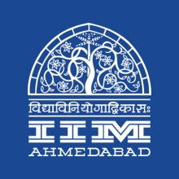

**PRESS RELEASE**

**IIMA - AFP Students Participate in a Cyclothon**

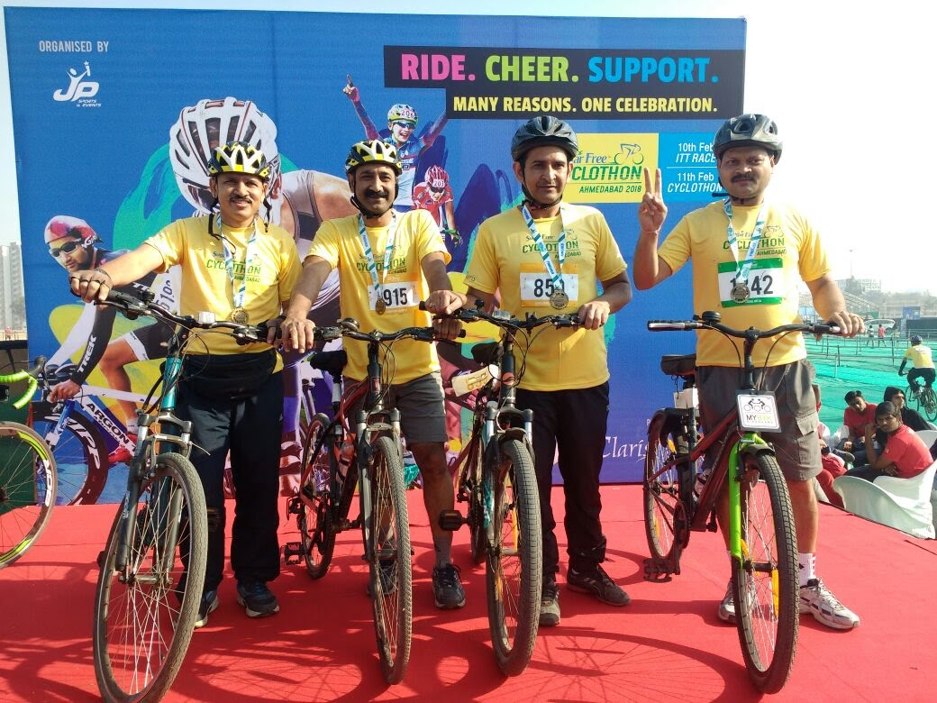

Students of IIMA - AFP at the event.

**February 11, 2018 | Ahmedabad**

In their quest for promoting fitness and concern for the environment, students from the Armed Forces Program and staff of IIM Ahmedabad participated in the third consecutive edition of Cyclothon held at Ahmedabad on February 11, 2018. The participation in the event was in various categories with IIMA personnel taking part majorly in the 50km and Green Ride category. The cycling enthusiasts at IIM Ahmedabad, with their numbers, progressively increasing, aim to promote healthy living and a pollution-free mode of commutation.

* The End of Text -

**About Indian Institute of Management Ahmedabad (IIMA)**

Established in 1961, the Indian Institute of Management, Ahmedabad (IIMA) is recognized globally for excellence in management education. One of the top management schools in the world, IIMA educates leaders of the enterprises.

The Institute’s strategic priorities include: strengthening connection with its various constituencies, including academics, practitioners, alumni, and the community; nurturing a high performance work environment of stretch, autonomy, and teamwork; and strategic growth while maintaining emphasis on quality.

As per the latest ranking by *The Economist*, IIMA is No. 1 School in the world on the parameter of opening up new career opportunities for students. The flagship Post Graduate Programme (PGP) is ranked 16th in the *Financial Times* Masters in Management Ranking 2016. As per the *Financial Times’* Global MBA Ranking 2016, IIMA’s Post Graduate Programme for Executives (PGPX) is ranked 24th in the World. IIMA has been ranked as #1 Management institute as per the National Institutional Ranking Framework (NIRF) rankings of Ministry of Human Resource Development, Government of India.

For media queries, please contact:

|  |  |
| --- | --- |
| Mr. Deepak Bhatt  Manager, Communications  Indian Institute of Management Ahmedabad  Ph: (079) 6632 4683  Email: mngr-comm@iima.ac.in | Ms. Mitaaly Naidu  PR Executive  Indian Institute of Management Ahmedabad  Ph: (079) 6632 4684  Email: pr@iima.ac.in |