

Press Release

IIMA hosts Financial Distress, Bankruptcy, and Corporate Finance Research Conference 2019

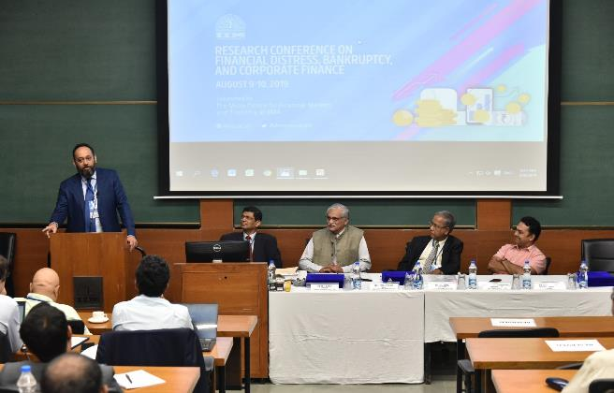

**Caption:** Mr. Peeyush Misra, Former Partner/Managing Director, Goldman Sachs; Dr. M.S. Sahoo, Chairperson, Insolvency and Bankruptcy Board of India; Prof. Errol D'Souza, Director, IIMA; Mr. U. K. Sinha, Former Chairman, Securities and Exchange Board of India and Dr. Krishnamurthy Subramanian, Chief Economic Advisor, Ministry of Finance, Government of India inaugurated the FDBCF 2019

**Ahmedabad | August 9, 2019:** Today was the inaugural of the two days (August 9-10, 2019) research conference on Financial Distress, Bankruptcy, and Corporate Finance (FDBCF 2019) at IIM Ahmedabad. The conference will facilitate interactions between policy makers, academia, lawyers, industry, international institutions, and other stakeholders.

The inauguration saw a very promising start with some of the most distinguished guests supporting the conference. Mr. Peeyush Misra, Former Partner/Managing Director, Goldman Sachs and Prof. Errol D'Souza, Director, IIMA presented valuable insights in their opening remarks. While Dr. Krishnamurthy Subramanian, Chief Economic Advisor, Ministry of Finance, Government of India and Mr. U. K. Sinha, Former Chairman, Securities and Exchange Board of India delivered the special addresses.

During his **keynote speech, Dr. M.S. Sahoo, Chairperson, Insolvency and Bankruptcy Board of India** quoted Hemingway - Indian companies went bankrupt ‘gradually, then suddenly’. Adding that the endeavor of every nation must be to provide economic freedom to every entrepreneur.

***Prof. Sanket Mohapatra,* *a coordinator of FDBCF 2019,*** *said, “We are grateful for the enthusiastic participation of researchers from reputed national and international universities and policy institutions in this conference. The research paper presentations will cover a range of topics related to financial distress and corporate finance, including (among others): the historical evolution of insolvency regulations in India, determinants of financial distress in the corporate sector and implications for banking sector, role of National Company Law Tribunals (NCLT) and insolvency professionals, addressing needs of operational and financial creditors, personal and cross-border bankruptcy, the importance of creditor rights and corporate governance, and financing of small and medium enterprises."*

The inaugural addresses were followed by an expert panel discussion on the gaps between policy and implementation in light of the IBC. Among other issues, the panel exchanged views on the practical problems encountered by banks in resolving the larger stressed accounts, and the role of the enabler that the IBC can play in the entire process.

This is the first conference supported by the newly-established **Misra Centre for Financial Markets and Economy** at IIMA. The Centre is addressing emerging issues that are highly relevant for policy, including supporting the FDBCF 2019 on the Insolvency and Bankruptcy Code (IBC) and its implications for the corporate sector, banking, and overall economy.

***Prof. Errol D’Souza, Director, IIMA*** *shared his thought on the importance of the centre,**“The mission of the Misra Centre for Financial Markets and Economy is to do applied research on the economic context affecting investments such as central banking and fiscal programs, financial intermediation to SMEs, financial inclusion, financial instruments and their market behavior, and to engage with stakeholders who are affected by as well as those who influence policies. The first event at the Centre was a lecture by Dr. Viral Acharya, Deputy Governor, RBI, on The Crowding Out Effects of Government Financing on 17th July, 2019. This conference is the second event and the presentations will provide insights on the way forward for addressing the concerns around insolvency in India.”*

***Prof. Abhiman Das, Chairperson - Misra Centre for Financial Markets & Economy at IIMA****added, “"Through the Misra Centre, we would like to facilitate wider scope for India specific policy oriented research by faculty and PhD students, within and outside India, working at the intersection of finance and economics. Further, the Centre would like to engage with relevant stakeholders who influence policies and contribute to the public debate on macro policy making.  In this context, FDBCFC is clearly one such event where both policy makers and researchers would discuss one of most critical issues grappling Indian corporates and banks today."*

Some of the participating institutes of the FDBCF 2019 are IIMB, IIMC, IIT-Delhi, IIT-Kharagpur, IMT-Nagpur, University of Delhi, National Law University - Assam, National Law School of India University - Bangalore, University School of Law and Legal Studies, GGSIPU - New Delhi including international institutes like Tulane Law School, New Orleans - USA, Lancaster University - UK, Deakin Law School - Melbourne, University of Minnesota, St. Petersburg School of Economics and Management, Saint Petersburg - Russia, University of Mons-FWEG - Belgium, University of São Paulo, Brazil. Insolvency and Bankruptcy Board of India (IBBI), Reserve Bank of India (RBI), National Institute of Public Finance & Policy (NIPFP), Centre for Advanced Financial Research and Learning (CAFRAL) are participants of the Policy Research Presentations.

More information on the invited speakers and the panel discussions are available at the conference website <https://conference.iima.ac.in/fdbcf2019/index.php>.

* The End –

**About Indian Institute of Management Ahmedabad (IIMA)**

Established in 1961, the Indian Institute of Management, Ahmedabad (IIMA) is recognized globally for excellence in management education. One of the top management schools in the world, IIMA educates leaders of the enterprises. The Institute’s strategic priorities include: strengthening connection with its various constituencies, including academics, practitioners, alumni, and the community; nurturing a high-performance work environment of stretch, autonomy, and teamwork; and strategic growth while maintaining emphasis on quality.

The flagship Post Graduate Programme (PGP) is ranked 21st in the Financial Times Masters in Management Ranking 2017. As per the Financial Times’ Global MBA Ranking 2017, IIMA’s Post Graduate Programme for Executives (PGPX) is ranked 29th in the World. The postgraduate program in food and Agri-Business (PGP-FABM) is ranked 1st in the Eduniversal Masters Ranking 2019. IIMA has been ranked as #1 Management institute as per the National Institutional Ranking Framework (NIRF) rankings of Ministry of Human Resource Development, Government of India.

*For media queries, please contact:*

**Deepak Bhatt, Manager, Communication**

Ph: (Cell) +91-9426229429, (O) +91-79-66324683, Email: [mngr-comm@iima.ac.in](mailto:mngr-comm@iima.ac.in)

**Mitaaly Naidu, Executive, Public Relations**

Ph: (Cell) +91-7069074816, (O) +91-79-66324684, Email: [pr@iima.ac.in](mailto:pr@iima.ac.in)