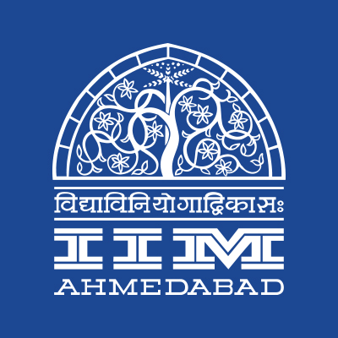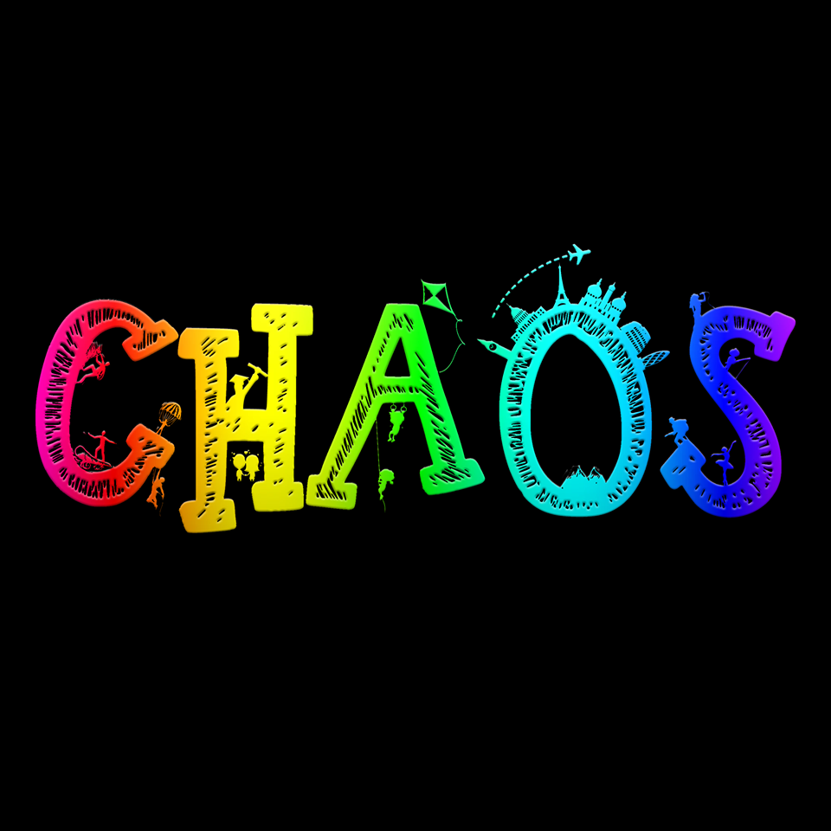

**PRESS RELEASE**

**IIMA readies itself for Chaos 2018**

**January 17, 2018 | Ahmedabad**

The Indian Institute of Management Ahmedabad is all set to host Chaos, its cultural festival from January 25, 2018 to January 28, 2018. The annual cultural extravaganza is one of the biggest cultural events across management institutes in the country with over 40000 individuals attending the previous editions of the event and artists like Shankar Mahadevan, Sonu Nigam, Sunidhi Chauhan, Amit Trivedi etc. performing at the same.

The theme of the festival this year is Colors of Life. The star performers of the fest are musical duo Salim-Sulaiman. The event will also host musical performance Benny Dayal, YouTube sensation Shirley Setia and rock band Agnee. Besides musical performances, the event will also include competitions in dance, drama and literary arena along with engaging workshops such as Radio Mirchi’s RJ Workshop, Certified Marketing & Digital Marketing workshops, Light Graffiti Workshop, Terribly Tiny Tales’ flagship Writing Workshop, The Corporate Simulation Workshop to name a few.

The fest would also comprise of speaker sessions by SS Rajamouli, director of blockbuster Bahubali and Balaji Vishwanathan- CEO of Invento Robotics. The fest is expected to receive over 20,000 registrations and host students from over 500 national institutes over the 4-day period which would include participants for events including Hip-notize, the Western dance competition, Natya Katha, the stage play competition, Crescendo, the Solo Singing Competition, Quizzes ranging from Sci-Tech, MELA, Business and Sports, and Parliamentary Debate. The fest also includes events for those having an entrepreneurial outlook hosting Swarnim: Entrepreneur of the Year, in association with SSIU, India's first startup and Innovation University, and Abhiyaan, a crowd funding competition.

With its extensive range of events, competitions, speakers, and artists, the fest promises something for everyone! For more information, please visit https://www.facebook.com/IIMA.Chaos/.

-End of Text-

|  |
| --- |
| **News in Brief**  Indian Institute of Management Ahmedabad is all set to host Chaos, its cultural festival from 25th January to 28th January, 2018. The annual cultural extravaganza is one of the biggest cultural events across management institutes in the country with over 40000 individuals attending previous editions. The event will host musical performances by musical duo Salim-Sulaiman, Benny Dayal, YouTube sensation Shirley Setia and rock band Agnee. The event will also include competitions in dance, drama and literary arena along with engaging workshops such as Radio Mirchi’s RJ Workshop, Graffiti Workshop, Terribly Tiny Tales’ flagship Writing Workshop, The Corporate Simulation Workshop to name a few. |

**About Indian Institute of Management Ahmedabad (IIMA)**

Established in 1961, the Indian Institute of Management, Ahmedabad (IIMA) is recognized globally for excellence in management education. One of the top management schools in the world, IIMA educates leaders of the enterprises.The Institute’s strategic priorities include: strengthening connection with its various constituencies, including academics, practitioners, alumni, and the community; nurturing a high performance work environment of stretch, autonomy, and teamwork; and strategic growth while maintaining emphasis on quality.

As per the latest ranking by *The Economist*, IIMA is No. 1 School in the world on the parameter of opening up new career opportunities for students. The flagship Post Graduate Programme (PGP) is ranked 16th in the *Financial Times* Masters in Management Ranking 2016. As per the *Financial Times’* Global MBA Ranking 2016, IIMA’s Post Graduate Programme for Executives (PGPX) is ranked 24th in the World. IIMA has been ranked as #1 Management institute as per the National Institutional Ranking Framework (NIRF) rankings of Ministry of Human Resource Development, Government of India.

For media queries, please contact:

|  |  |
| --- | --- |
| Shubham Varshney  Marketing & PR Cell, Chaos (PGP-2)  Indian Institute of Management Ahmedabad  Ph: (Cell) +91-7503602678  Email: p16shubhamv@iima.ac.in | Aashish Gupta  Marketing & PR Cell, Chaos (PGP-2)  Indian Institute of Management Ahmedabad  Ph: (Cell) +91-8090026763  Email: p16aashishg@iima.ac.in |