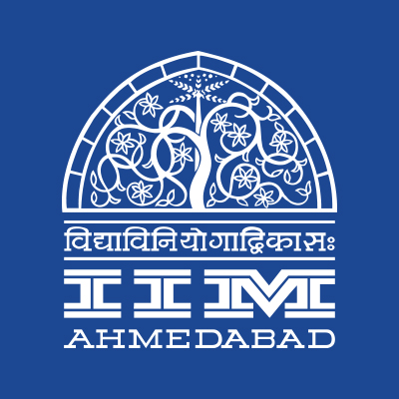

**PRESS RELEASE**

**IIMA to host Inter-College sports event – ‘Shaurya’**

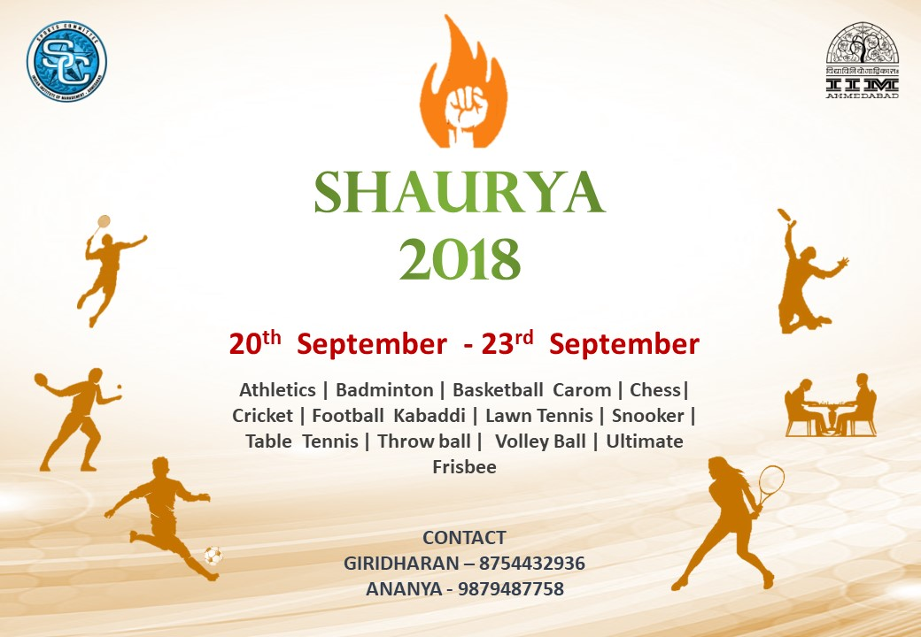

**September 19, 2018 | Ahmedabad**

Shaurya, the annual inter-college sports fest of the Indian Institute of Management Ahmedabad (IIMA), is scheduled to take place from the 20th to 23rd September, 2018. IIMA’s sports committee or SportsComm as it is popularly called, has been instrumental in maintaining the sporting culture on campus and is going to organize the fest with a talented bunch of 46 “SportsCommers” this year. While Shaurya is an effort to use sports as an avenue to learn the basics of management and inculcate a spirit of team play and resilience, it is also a platform for various sports enthusiasts to showcase their athletic prowess. The event, spread over a period of four days, is expected to witness a footfall of over 5,000 participants. It has already garnered registrations from over 150 teams of more than 30 colleges across the country, including IIFT, SCMHRD, NMIMS and NID.

The fest provides a good mix of 15 sports. While Frisbee, Football and Cricket are all-time favorites on the campus, indoor sports like Carom, Chess and Snooker have also seen increased enthusiasm this year. The league format matches, followed for most of the sports, are set to take the adrenaline levels higher, as colleges compete for the winner’s award.

The flagship sports fest of IIMA is all set to provide an unmatched experience to the participating colleges as well as the student community. It epitomizes Will Carling’s saying, “success in management and success in sports are both derived from the same basic principles”. While the fest is actively doing the rounds in campus, it has also attracted attention from a lot of people in and around Ahmedabad, through the official [Facebook Page](https://www.facebook.com/sportscomm.iima) of IIMA SportsComm.

As Shaurya inches closer, the teams are pulling up their socks to put up their best show. The fervor and energy of the participants is reflective in the rigorous practices being carried out by the various teams. Over the years, along with enthusiastic participation from the student community at IIMA, Shaurya has also witnessed active participation from the IIMA alumni. The trend continues this year with various alum teams for sports such as Frisbee and Football participating in the fest. It would be nothing short of a spectacle to witness the soaring energy levels on campus during the four days of Shaurya.

*Jainesh Prakash Doshi, Sports Secretary, IIM Ahmedabad said, “We are looking forward to hosting the participating teams and providing a seamless platform for promotion of sports as a culture. With an extensive participation from 30 colleges, we are thrilled to make Shaurya a successful and enriching experiencing for everyone”.*

More details can be found at <https://www.facebook.com/sportscomm.iima/>

-End of Text-

**About Indian Institute of Management Ahmedabad (IIMA)**

Established in 1961, the Indian Institute of Management, Ahmedabad (IIMA) is recognized globally for excellence in management education. One of the top management schools in the world, IIMA educates leaders of the enterprises.

The Institute’s strategic priorities include: strengthening connection with its various constituencies, including academics, practitioners, alumni, and the community; nurturing a high performance work environment of stretch, autonomy, and teamwork; and strategic growth while maintaining emphasis on quality.

As per the latest ranking by *The Economist*, IIMA is No. 1 School in the world on the parameter of opening up new career opportunities for students. The flagship Post Graduate Programme (PGP) is ranked 16th in the *Financial Times* Masters in Management Ranking 2016. As per the *Financial Times’* Global MBA Ranking 2016, IIMA’s Post Graduate Programme for Executives (PGPX) is ranked 24th in the World. IIMA has been ranked as #1 Management institute as per the National Institutional Ranking Framework (NIRF) rankings of Ministry of Human Resource Development, Government of India.

For media queries, please contact:

|  |  |
| --- | --- |
| Jainesh Prakash Doshi  Sports Secretary (PGP-2)  Indian Institute of Management Ahmedabad  Ph: (Cell) +91-8237373087  Email: p17jaineshd@iima.ac.in | Gayatri Nair  Member, PR Team, Media Cell  Indian Institute of Management Ahmedabad  Ph: (Cell) +91-8197720191  Email: p18gayatri@iima.ac.in |