

**IIMA’s 12th PGPX Batch Inaugurated**

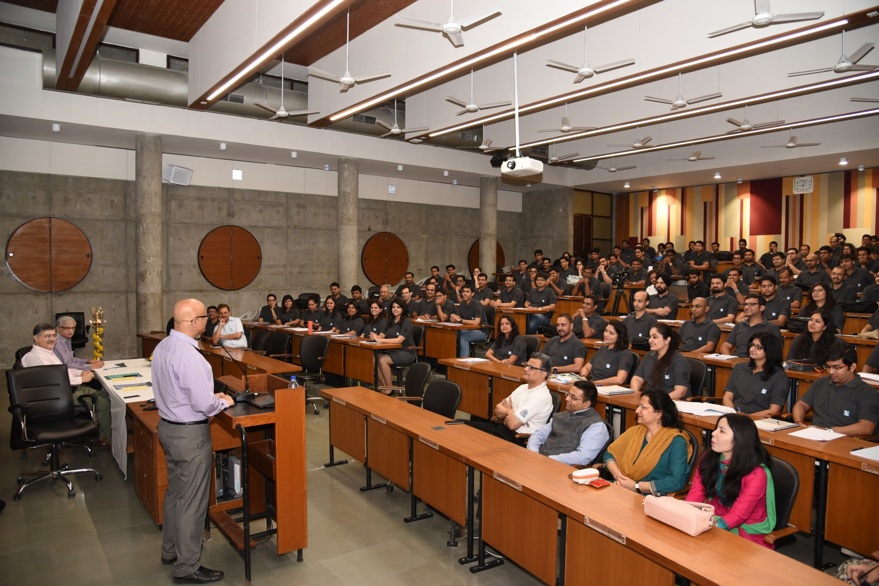

***Caption: PGPX 2017-18 Batch Induction day***

**April 19, 2017, Ahmedabad**: Twelfth batch (12th) of the Indian Institute of Management, Ahmedabad (IIMA)’s one year full time residential Post Graduate Programme in Management for Executives (PGPX) for 2017-18 was inaugurated on Thursday, April 13, 2017 by Director, Professor Ashish Nanda, and welcomed by Prof. Sunil Sharma, Chairperson, PGPX and Prof. Errol D’souza, Dean Faculty at Indian Institute of Management Ahmedabad (IIMA), New campus.

One hundred and fifteen students have joined the PGPX-XII batch. The 2017-18 batch has an average GMAT score of around 700, average age of around 32 years, average total work experience of 8.5 years, and average international experience of two years.​ ​

The current batch is also very diverse in terms of educational backgrounds (25% are non-engineers), work-experience (18 industries, innumerable functional areas, and 102 companies), nationality (three international participants), gender (25% of the batch are women), and international work-experience (57% of the batch has worked abroad before joining PGPX).

Launched in 2006, more than 900 students have graduated from PGPX so far​. ​Till 2016-17, the PGPX intake was 90. ​This year the institute has ​added one more section to enhance learning experience of participants. ​Accordingly, 115 students have been admitted this year.

​*Professor Sunil Sharma, Chairperson, PGPX, exhorted the incoming batch to focus on learning. Speaking on the occasion, he said, “To me, everybody who is part of IIMA family is privileged. Use this opportunity to give expression and lift to your wings. Many have done this before you and they have emerged from this “tapovan” and “tapasya” to become extraordinary problem solvers and leaders.​”*

**About IIMA:**

Established in 1961, the Indian Institute of Management, Ahmedabad (IIMA) is recognized globally for excellence in management education. One of the top management schools in the world, IIMA educates leaders of the enterprises. The Institute’s strategic priorities include: strengthening connection with its various constituencies, including academics, practitioners, alumni, and the community; nurturing a high performance work environment of stretch, autonomy, and teamwork; and strategic growth while maintaining emphasis on quality. As per the latest ranking by The Economist, IIMA is No. 1 School in the world on the parameter of opening up new career opportunities for students. The flagship Post Graduate Programme (PGP) is ranked 16th in the Financial Times Masters in Management Ranking 2016. As per the Financial Times’ Global MBA Ranking 2016, IIMA’s Post Graduate Programme for Executives (PGPX) is ranked 24th in the World.

**IIMA Media Contacts**

|  |  |
| --- | --- |
| **Mr. Deepak Bhatt**  Manager, Communications  Email: [mngr-comm@iima.ac.in](mailto:mngr-comm@iima.ac.in) Phone: +91-79-66324683 | **Ms. Mitaaly Naidu**  PR Executive, Communications  Email: [pr@iima.ac.in](mailto:pr@iima.ac.in) Phone: +91-79-66324684 |