

**PRESS RELEASE**

**HTSAS 2.0 - Interactive session with Mr. Rajnish Dhall**

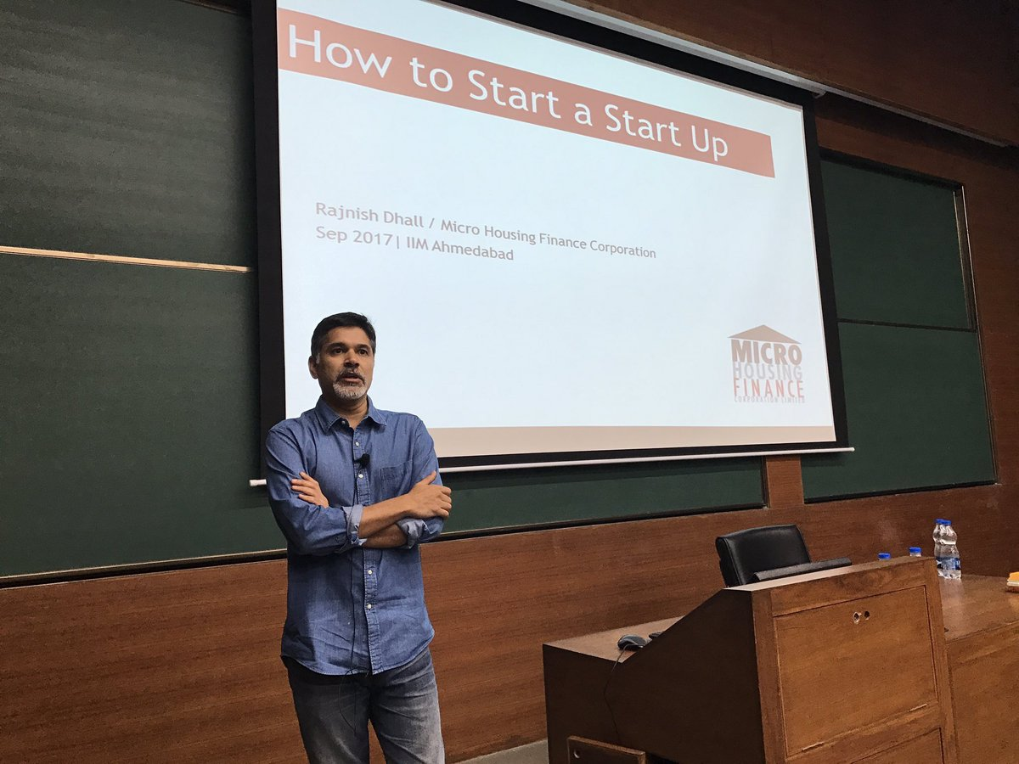

*Mr. Rajnish Dhall addressing audience at IIMA*

**October 9, 2017 | Ahmedabad**

With the vision to impart the experiences and learnings of seasoned entrepreneurs and investors to the entire country, the Entre cell at IIM Ahmedabad (IIMA) as part of it’s How to Start a Startup 2.0 series hosted Mr. Rajnish Dhall, Managing Director of Micro Housing Finance Corporation Limited, a company which efficiently and sustainably enables access to housing finance services to the underprivileged and unserved segments of the population. The interaction was held on September 27, 2017 and witnessed a packed house at PP Gupta Auditorium.

Mr. Rajnish, an alumnus of IIMA, worked with the American Express bank for 15 years post his PGDM, after which he worked for 2 years in the social sector before he co-founded MHFC in 2008. Talking about the major factors which influenced his foray into social entrepreneurship, he recalled that one of the primary drivers was a course under Prof. Anil Gupta at IIMA where he got an opportunity to go out to villages and work with the people there for a few days. The idea of providing financial services to the underprivileged to buy houses originated when his driver asked him for a loan of INR 3 lakhs to buy a house. His experience in the risk and banking industries helped him deep dive into the nitty-gritty of the micro-finance industry.

With 30% people living in cities today and 125 million homes required, Mr. Rajnish mentioned that even if these homes are built, the question of who would finance their buying will always remain. With such a large untapped market, MHFC started with the vision to provide housing loans for the financially excluded lower income segments. Offering the same offering as that of the other mainstream banks like HDFC, Mr. Rajnish added that the only difference between such banks and MHFC is the target market.

Breaking the myth that social entrepreneurship organizations are not profitable, Mr. Rajnish stressed that MHFC was not started as a charity organization but with a strong focus to turn profitable as soon as possible. The company broke even in the second year from its inception and has been growing rapidly ever since. With over 16,000 loan sanctions currently, MHFC has an NPA of 1% with a return on equity of 9% and made a profit of INR 6 crores last year. Using a good deal of technology and data analytics, the company has developed its own formula for assessing a person’s income and payback capacity and has been widely successful in getting back its loans.

Mr. Rajnish spoke passionately about being an entrepreneur and more so about being a social entrepreneur. He said that although there will be significant challenges starting from the long work hours to taking care of every aspect of the startup including building a new team, financing, finding customers, setting systems and processes, the ultimate satisfaction which this role gives is unparalleled. He added that with the current buzz about entrepreneurship in the industry, there has not been a better time to start up as a social entrepreneur. With good mentors and massive opportunities and funding, he urged every budding entrepreneur to go ahead and take the leap.

*Looking back at his journey with MHFC for the past 9 years, he said that one of his most significant learnings was that there isn’t a right model or strategy for success. He also added that compassion and passion are highly essential for being a social entrepreneur.* With partners being extremely critical as the company grows, he recommended choosing wisely and ensuring that there is excellent compatibility within the team. Ultimately, he summarized the experience of being a social entrepreneur as liberating and at the end of the day even if the venture fails, some good would have surely come off it.

-End of Text-

**About Indian Institute of Management Ahmedabad (IIMA)**

Established in 1961, the Indian Institute of Management, Ahmedabad (IIMA) is recognized globally for excellence in management education. One of the top management schools in the world, IIMA educates leaders of the enterprises.

The Institute’s strategic priorities include: strengthening connection with its various constituencies, including academics, practitioners, alumni, and the community; nurturing a high performance work environment of stretch, autonomy, and teamwork; and strategic growth while maintaining emphasis on quality.

As per the latest ranking by *The Economist*, IIMA is No. 1 School in the world on the parameter of opening up new career opportunities for students. The flagship Post Graduate Programme (PGP) is ranked 16th in the *Financial Times* Masters in Management Ranking 2016. As per the *Financial Times’* Global MBA Ranking 2016, IIMA’s Post Graduate Programme for Executives (PGPX) is ranked 24th in the World. IIMA has been ranked as #1 Management institute as per the National Institutional Ranking Framework (NIRF) rankings of Ministry of Human Resource Development, Government of India.

For media queries, please contact:

|  |  |
| --- | --- |
| Umang Shah  HTSAS 2.0 Head (PGP-2)  Indian Institute of Management Ahmedabad  Ph: (Cell) +91-9870044780  Email: p16umangcs@iima.ac.in | Vaishnavi Kumar  External Media Relations (PGP-1)  Indian Institute of Management Ahmedabad  Ph: (Cell) +91-9654853483  Email: p17vaishnavi@iima.ac.in |