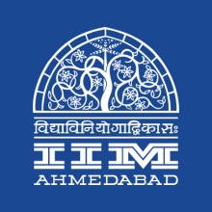

**PRESS RELEASE**

**The fourth IIMA HR Leadership Conclave Series 2019 held in Bengaluru**

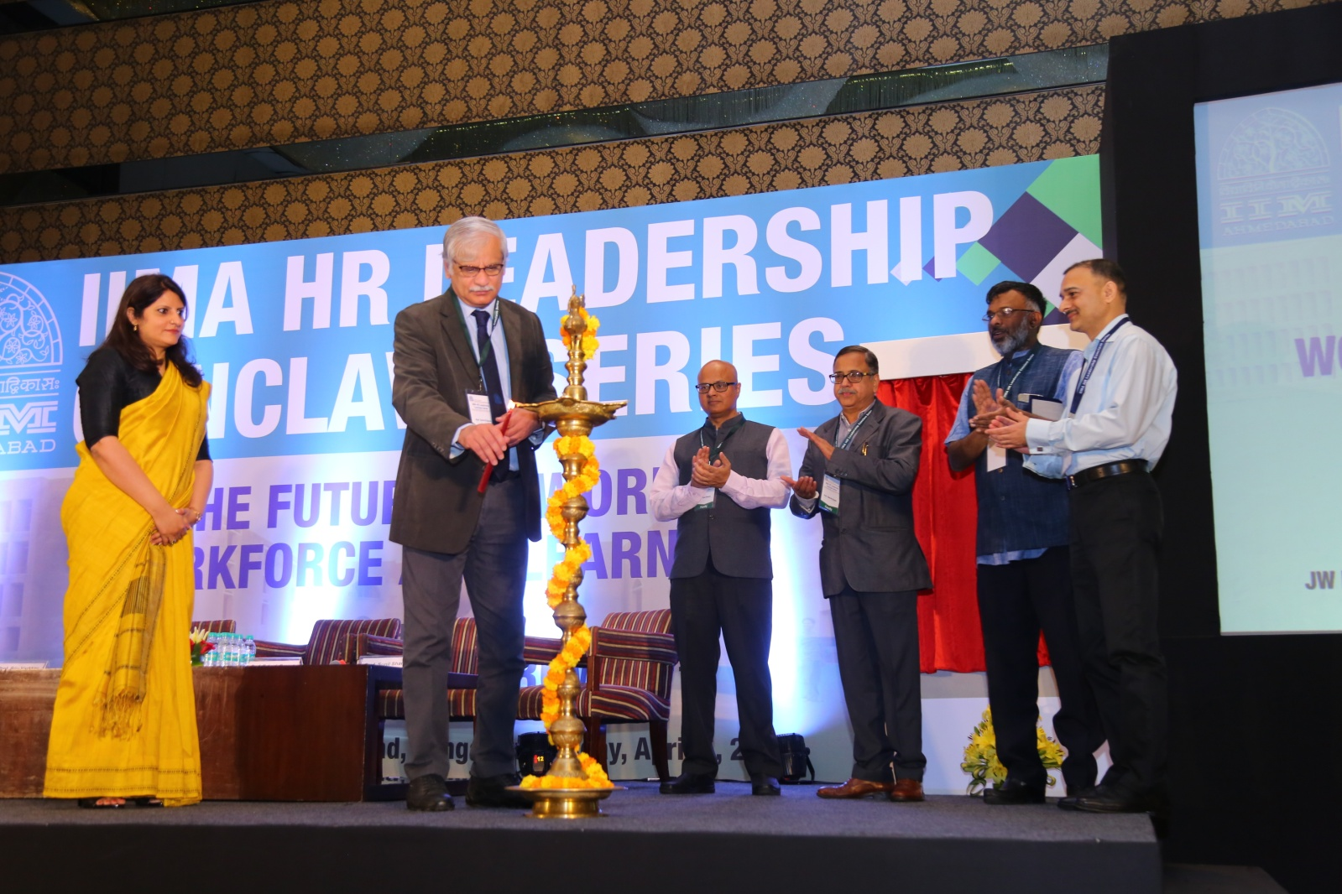

**Caption:** (l-r) Kirti Sharda, Prof. of Organizational Behaviour, IIMA; Prof. D’Souza, Director, IIMA; Prof. Sunil Sharma, Chairperson – EEP, IIMA; Prof. Rakesh Basant, Dean – A&ER, IIMA; Prof. Biju Varkkey, Faculty Chair of IIMA HR Leadership Conclave 2019 and a delegate of the conference lighting the lamp.

**Bengaluru ∣ April 5, 2019:** IIMA organized the fourth leg of its HR Leadership Conclave on ‘The Future of Work, Workforce and Learning’ today at JW Marriott, Vittal Mallya Road, Bengaluru. Last year, the Conclave was held in Hyderabad with a successful response.

This year, eminent panellists shared their expert opinion on two topics “Learning & Development needs of new age & fast growing organizations” and “Storytelling for learning & change”.

*"Each year we use this forum as an opportunity for academia and practice to discuss about HR leadership skills and practices. While we showcase some of the cutting work done by the faculty members, which can impact practice through such interactive platforms, we also learn from organisations about their challenges and real time decision dilemmas. We use the insights to incorporate new innovative solutions in our current and future executive education programmes, teaching and research at IIMA.", said Prof. Biju Varkkey, Faculty Chair of IIMA HR Leadership Conclave 2019.*

This conclave focussed on the emerging and latest practices in Learning and Development function globally and how it can be applied in the organizations to drive Core Business Agenda.

*Prof. Errol D’Souza, Director, IIMA, said “IIMA proactively connects with Corporate, Government, Alumni and Researchers over global forums like HR Leadership Conclaves to discuss the most recent and emerging trends in organizations and management.”*

The participants also got insights from the industry leaders on the current practices in the context of Learning and Development. The conference was attended by Senior Level Professionals from HR and other areas in Skill Development, Technology Adoption and Competency Development from various organizations.

**About IIMA Executive Education Programme (EEP):**

Set up in 1961 by the Govt. of India and the Govt. of Gujarat state in a true spirit of ‘Public-Private Partnership’, IIMA have had started off with Executive Education wing in 1961 which was followed by its flagship programme “PGP” in 1964. IIMA has been consistently ranked as the premier management school in the country by several national agencies. IIMA has also been acknowledged internationally by a renowned international association named EFMD (European Foundation for Management Development).

*Prof. Sunil Sharma, Chairperson – EEP, IIMA said, “Executive Education is an integral part of IIMA’s learning platform. We partner with organizations and working professionals to create learning opportunities focused on contemporary management practices. Our executive education programs are anchored in actionable learning through real business case discussions, simulations, and experiential learning. IIMA faculty members bring their own research and consulting experience into the class room for solving business problem”*

Organizations in this ever-changing world strive to update the knowledge and skills of its executives for coping with the increasing competition through popularly known as Management Development Programme or nowadays known as Executive Education in sharpening their management leadership skills through discussions, group exercises, simulations, networking events etc. which aid cross-fertilisation and innovation.

IIMA’s Executive Education is a major activity through which it has been designing and conducting open enrolment and customised programs for Governments, Corporates, Multi-national companies and parastatals like regulatory bodies, on a wide variety of topics including policy issues.

**For media queries, please contact: Mr. Deepak Bhatt**

Manager, Communications

Ph: (Cell) +91-9426229429, (O) +91-79-66324683

Email: [mngr-comm@iima.ac.in](mailto:mngr-comm@iima.ac.in)

**Ms. Mitaaly Naidu**

Executive, Public Relations

Ph: (Cell) +91-7069074816, (O) +91-79-66324684

Email: [pr@iima.ac.in](mailto:pr@iima.ac.in)