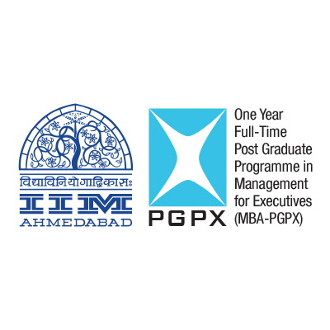

**IIM AHMEDABAD**

**MBA-PGPX Final Placements 2020**

**September 2, 2020**

The final placement process for the Class of 2020 of the One Year MBA Programme, the full-time Post Graduate Programme in Management for Executives (PGPX) at IIM Ahmedabad completed successfully in July end. As every year, the final placement report was audited by an external agency and finalized on September 2, 2020.

The graduating students accepted a total of 120 offers from firms cutting across sectors such as Consulting, BFSI, Conglomerates, FMCG, E-Commerce, Technology, IT and ITES, Energy, Logistics, Pharma, and Manufacturing. The participants of the fourteenth batch of PGPX came from varied backgrounds with rich experience ranging from 4 to 16 years. Recruiters visited campus to select candidates for their mid-senior and senior level management positions. Students were offered positions such as Co-CEO, Chief Product Executive, Vice President, Director, Associate Vice-President, National Head, General Manager, Senior Advisor to CEO, Young Leadership Programs, Principal Consultant, Senior Manager, Product Manager, Client Partner and Offering Manager.

A total of 130 firms participated in this year’s campus placement process, offering a spectrum of over 300 different roles to our PGPX graduates. Information Technology firms formed the largest sector of offers with 42 accepted offers, followed by Online Services, Consulting and BFSI, with 14, 13, and 11 accepted offers respectively.

Firms that rolled out offers to PGPX students included AB InBev, Accenture, Adani Group, Aditya Birla Management Corporation, Agarwal Packers & Movers, Amazon, Atos Syntel, Axis Bank, Bank of America, Bharti Airtel, Cepheid India, Citi, Decimal Technologies, Deloitte, Deshpande Foundation, ElasticRun, Ernst and Young, FIITJEE, Genpact, Havmor, Hexagon, Honeywell, ICICI Bank, Indegene, KEC International, L&T Infotech, Microsoft, Magicpin, Mastercard, Near India, NEC, NISG, NPCI, Optum, Persistent Systems, Praxis Global, PwC, Schindler, Shell, Stryker, Sutherland, Technova, Trident , Udaan, Vikram Solar, Visionet Systems, Zensar and Zama Organics. Genpact made the largest number of offers.

**Prof. Amit Karna, Chairperson of the Placement Committee,** said *“The outcome of the placement process of the PGPX  Batch of 2020 demonstrates the strength of the programme and the value that recruiters see in hiring our students for their talent needs at mid to senior level positions. We were delighted to welcome over 20 new recruiters from across sectors who were able to hire the best talent for their organizational needs. We are grateful for the faith that the recruiters – both new and regular – continued to place in the placement process and our students. We wish our graduates great success in their careers.”*

**Adarsh Sharma, PGPX Recruitment Secretary,** added *“**We are delighted to share the excellent placement results of PGPX Class of 2020. In the last couple of years, we have witnessed a growing demand for candidates from programs such as PGPX in organizations. We have seen an increased interest from E-commerce, Healthcare & Life Sciences and Fintech companies well complimented by the traditional recruiters from IT, Consulting, Pharma & Conglomerates. The experienced and diverse cohort of the programme assures a greater alignment between the organizational needs and the candidate’s aspirations. We have strengthened our relationship with our long-associated recruiters and have partnered with many new organisations this year. We take pride in the continued trust the organisations have bestowed upon IIMA’s PGPX Class of 2020 and are confident that PGPX graduates will continue to excel in every role and responsibility undertaken by them.”*

IIM Ahmedabad encourages students to take up entrepreneurship as a career, and this year also three students have taken entrepreneurship to pursue their ideas under the guidance and mentorship of Centre for Innovation Incubation and Entrepreneurship (CIIE.CO). These students will be given a placement holiday of two years.

**About PGPX @ IIMA**

The Post Graduate Programme in Management for Executives (MBA-PGPX) is one of the leading one-year, full-time, residential MBA programmes in the world. Carefully designed by the Indian Institute of Management Ahmedabad for bright, enthusiastic, and aspirational executives with substantial professional experience, the PGPX programme attracts top talents from diverse industries, cultures, and geographies. Each year, the PGPX programme participants are hand-picked by the faculty of IIM Ahmedabad to ensure a rich, meticulous, and well-balanced in-class learning experience for all participants. The batches that have graduated have been welcomed by corporate houses in need of management talent at senior levels – from senior managers and consultants to general managers and CXOs. This reinforces our original belief that a programme was needed to add value to growing organizations across the world at leadership levels. For the past five years including 2020, with ‘Get-Ready-for-Top-Management' focus, the PGPX programme is consistently ranked among top-10 in the world on the Financial Times Career Progression category. The 'Indian Ranking 2019', prepared by MHRD's National Institutional Ranking Framework (NIRF), rated IIM Ahmedabad as the 'Best Management Institute ' in India.

Detailed placement report of PGPX 2020: <http://bit.ly/PGPX2020IPRS>

Past placements reports of PGPX: <http://bit.ly/PGPXReports>