

**PRESS RELEASE**

The 52nd Operations Research Society of India (ORSI) and International Conference will be held at IIMA

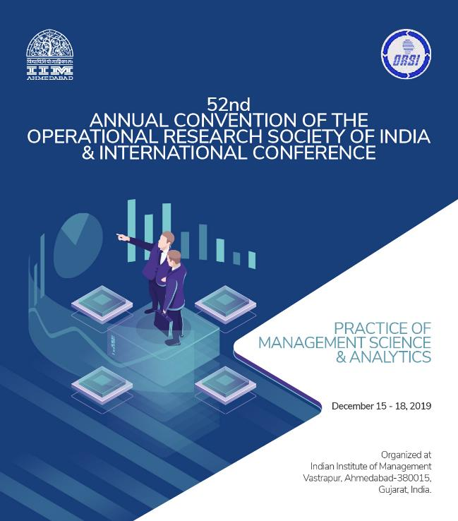

**December 13, 2019 | Ahmedabad: The** 52nd Conference of Operations Research Society of India (ORSI) and International Conference will be held at Indian Institute of Management, Ahmedabad from 15 to 18 December 2019. This conference will bring together leading academicians, researchers, practitioners from corporate, government & industry and students from around the world interested in promoting the concept of informed decision making in business, industry and public policy.

Prof. Goutam Dutta, the current and 43rd President of ORSI and the Conference Chair, said “*Operations Research is the art and science of winning wars without actually fighting. This conference will be a platform for the exchange of ideas among academicians to understand how Operations Research is being applied in the real world and how it can help firms to win the battle of competition and be more profitable.”*

Director IIMA, Errol D’Souza also added, “*Future in Public Policy in India will be guided by Operations Research, Management Science and Analytics. We hope that bureaucrats, public policy matters and government ministers will make effective use of public policy as it is in Western countries.”*

About 225 people are expected to participate and share their research work and ideas in this 3-day conference. Leading industries like State Bank of India, Bharat Petroleum, Tata Steel, JSW, JDA are sponsoring the conference. It also has OPEX analytics, OPTYM, AMPL as International sponsors. In addition to that, we have support from the Bangalore chapter of ORSI, Sharda University, Springer Publication - the official publishers of ORSI.

The conference will have Prof. Ramaya Krishnan - President of INFORMS, Prof. Paulo Toth - Former President of IFORS (International Federation of Operational Research Societies), Director IIMA and the current President – ORSI on the dais to inaugurate the conference.

One of the crucial features of this conference will be recently started ORSI Prizes (popularly known as Practice Prize) in practice of Operations Research, Management Science & Analytics where 3 corporates and Indian Army will be competing for the practice prize in 6 sessions.

ORSI was set up in the year 1957 by the former statistician P. C. Mahalanobis who was the Deputy Chairman of the Planning Commission and the Founder of Indian Statistical Institute, India. ORSI has its headquarters in Kolkata and has 16 chapters across different cities of India.

To know more in detail: <https://conference.iima.ac.in/orsi2019/>

* The End -