

Launching of the biggest stock pitch event in India **– the Motilal Oswal Think Equity Think QGLP Contest at the Red Brick Summit 2018**

**FOR IMMEDIATE RELEASE**

Name of the contest: Motilal Oswal Think Equity Think QGLP Contest 2018 **|** Type: Stock Pitch (Business)

**Ahmedabad, August 31, 2018** – The Flagship Management Symposium of IIM Ahmedabad - The Red Brick Summit 2018 in collaboration with Motilal Oswal proudly announces the second edition of arguably the biggest stock pitch event in India – the Motilal Oswal Think Equity Think QGLP Contest 2018. The contest provides a great forum for B-school students to test their stock-picking skills, present the same to a distinguished panel of investors, and win attractive cash prizes along the way. The students currently pursuing MBA or equivalent degree at any business school across India are invited to participate in the “Think Equity Think QGLP Contest 2018”.

Last year, students from 54 top B-Schools from across India participated in the first edition of the contest. In the finals held on October 2, 2017 during The Red Brick Summit at the IIMA campus, ISB Mohali emerged as the winner followed by IIM Rohtak and IIM Bangalore securing 1st and 2nd runner up positions, respectively.

As a part of the competition, teams will identify an equity stock worth making a pitch by applying QGLP stock-picking process. The top entry from each college will be assessed by an internal team of investment experts from Motilal Oswal led by Mr Raamdeo Agrawal, Chairman, Motilal Oswal Asset Management Company. The 10 best entries will qualify for the contest finals to be held on Tuesday, 2nd October 2018, at the IIM Ahmedabad campus during The Red Brick Summit.

The qualifying finalists will need to present their stock pitch to a three-member jury, chaired by Mr Raamdeo Agrawal. The jury will finally select the top three winners based on the following Stock Pitch evaluation criteria: Applicability of QGLP principles, Quality of idea, Depth of analysis/insights, Financial workings/model, Presentation skills, Q&A session.

**Prizes:**

Total Cash Prizes to be won – **INR 13 Lakhs**

The finalists will receive attractive cash prizes – **Winner INR 5,00,000/-,** **First runner-up INR 3,00,000/-,** **Second runner-up INR 1,50,000/-,** and **7 qualifiers will get INR 50,000/- each**. Each finalist will receive a **Certificate of Appreciation**.

--- Text end

**About Indian Institute of Management Ahmedabad (IIMA)**

Established in 1961, the Indian Institute of Management, Ahmedabad (IIMA) is recognized globally for excellence in management education. One of the top management schools in the world, IIMA educates leaders of the enterprises.

The Institute’s strategic priorities include: strengthening connection with its various constituencies, including academics, practitioners, alumni, and the community; nurturing a high performance work environment of stretch, autonomy, and teamwork; and strategic growth while maintaining emphasis on quality.

IIMA has been ranked as #1 Management institute as per the National Institutional Ranking Framework (NIRF) rankings 2018 of Ministry of Human Resource Development, Government of India. The flagship Post Graduate Programme (PGP) is ranked 21st in the *Financial Times* Masters in Management Ranking 2017. As per the *Financial Times’* Global MBA Ranking 2018, IIMA’s Post Graduate Programme for Executives (PGPX) is ranked 31st in the World.

For media queries, please contact:

|  |  |
| --- | --- |
| Himanshu TandonPR & Media Relations, The Red Brick Summit Indian Institute of Management Ahmedabad Ph: (Cell) +91-9818269147 Email ID: [p17himanshut@iima.ac.in](mailto:p17himanshut@iima.ac.in) | Kashika LalPR & Media Relations, The Red Brick Summit Indian Institute of Management Ahmedabad Ph: (Cell) +91-7838526332 Email ID: [p17kashika@iima.ac.in](mailto:p17kashika@iima.ac.in) |

**About The Red Brick Summit (TRBS)**

The Red Brick Summit (to be referred as TRBS henceforth) is the annual management symposium of Indian Institute of Management Ahmedabad. The current edition of the summit is going to be held this year from 29th September to 2nd October at IIMA campus in Vastrapur, Ahmedabad.

Last year, the symposium witnessed 40,000 footfall and received over 18,000 registrations from over 450 colleges across India. The symposium reached about 10 lac+ people through PR publicity. For the current edition, we anticipate even higher footfall and participation. There are 20 business events, 14 workshops, 4 panel discussions and 17 speaker sessions as part of the symposium.

**About Motilal Oswal AMC**

Motilal Oswal Asset Management Company Ltd. (MOAMC) is a public limited company incorporated under the Companies Act, 1956 on November 14, 2008, having its Registered Office at 10th Floor, Motilal Oswal Tower, Rahimtullah Sayani Road, Opposite Parel ST Depot, Prabhadevi, Mumbai - 400025. Motilal Oswal Asset Management Company Ltd. has been appointed as the Investment Manager to Motilal Oswal Mutual Fund by the Trustee vide Investment Management Agreement (IMA) dated May 21, 2009, executed between Motilal Oswal Trustee Company Ltd. and Motilal Oswal Asset Management Company Ltd. The AMC is also registered with SEBI under SEBI (Portfolio Managers) Regulations, 1993 as Portfolio Manager vide Registration No. INP000000670.

**Jury Members – Brief Profile:**

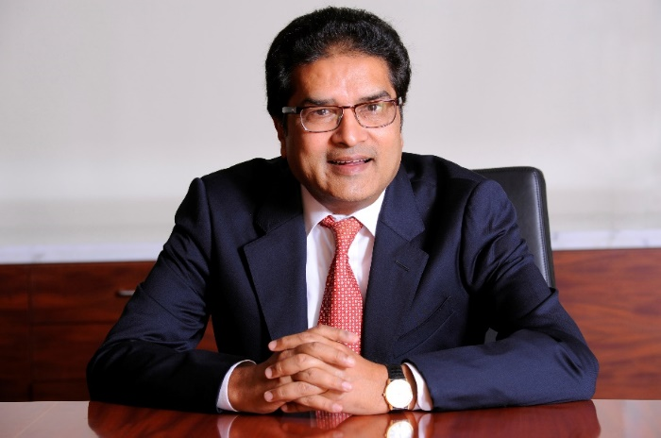

**Mr Raamdeo Agrawal**

Mr Raamdeo Agrawal is the co-founder and Joint Managing Director of Motilal Oswal Financial Services Ltd and Chairman of Motilal Oswal Asset Management Company (MOAMC). A Chartered Accountant, he is a pioneer of equity research in India and has been authoring the Annual Motilal Oswal Wealth Creation Study for the last 22 years. Under his Chairmanship, MOAMC’s assets under management have grown rapidly to the current level of nearly INR 40,000 crores.



Mr Sandeep Kothari

Mr Sandeep Kothari is Portfolio Advisor to Fidelity’s FF India Focus Fund.A qualified Chartered Accountant, Mr Kothari has a long stint of over 15 years with Fidelity, starting in 2002 as an Investment Analyst. He has total equity market experience of over 25 years, including stints with Credit Lyonnais as Senior Investment Analyst and with CLSA India as Global Pharma Analyst. He is an avid marathon runner, and hasparticipated in marathons both in India and abroad.

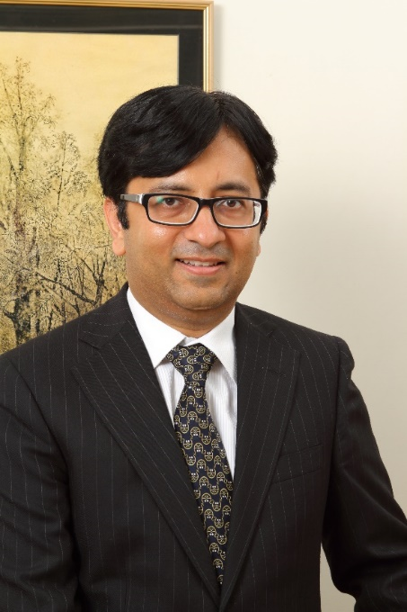

Mr Rajeev Thakkar

Mr Rajeev Thakkar is currently the Chief Investment Officer and Director at PPFAS Mutual Fund. He is a strong believer in the school of Value Investing, and is heavily influenced by Warren Buffett and Charlie Munger’s approach. He is a regular contributor to Mint newspaper and has also appeared on business channels such as Bloomberg India TV and ET Now. He is a qualified Chartered Accountant, Cost Accountant and CFA Charter holder.