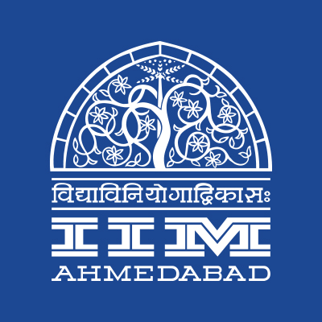

**PRESS RELEASE**

**Chaos continues at IIMA**

*-*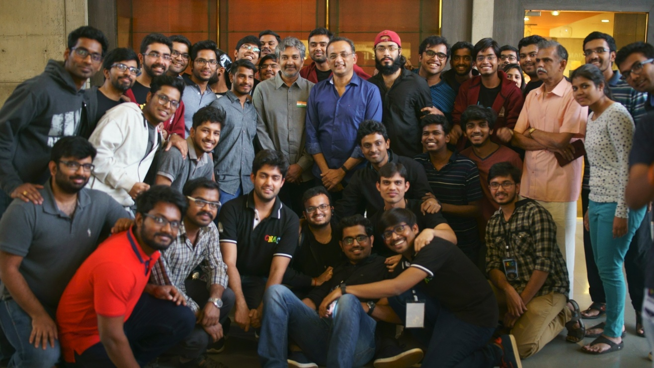

*- IIMA students with Mr. S S Rajamouli and Mr. Shobu Yarlagadda*

**January 28, 2018 | Ahmedabad**

The annual cultural extravaganza of the Indian Institute of Management Ahmedabad (IIMA), Chaos 2018 continued to enthrall students from around the country with energetic performances from Shirley Setia and Benny Dayal over the past two days.

The second ProNight of Chaos 2018 witnessed Shirley Setia, the Indo-Kiwi YouTube sensation mesmerize a packed crowd with her presence, personality and performance at IIMA’s iconic LKP stage. In an exclusive backstage interview with Shirley, she stated that she loves what she does and it was her heart that brought her here. She also stated that she would consider joining this campus (IIMA) if she thinks about getting an MBA.

The penultimate ProNight of Chaos 2018 saw Benny Dayal perform to a packed crowd. The 33-year old power performer backed by his band enthralled the audiences with renditions of his popular Bollywood tunes. In a backstage interview, he said that music is what he would do all his life while the pursuit of happiness was his greatest inspiration.

As a part of its speaker series, Chaos 2018 was privileged to host Balaji Viswanathan, a noted author, entrepreneur and the most viewed Writer on Quora. Mr. Viswanathan delivered a thought provoking talk about the startup landscape of India. He stated that a business model that does not deliver revenues from the beginning will face challenges. His advice to budding entrepreneurs was to focus on the higher end while warning them that most startups under-price their offerings. He said that a startup making revenues will attract investors on its own.

The headline event from Chaos 2018 was the speaker session by Mr. S S Rajamouli and Mr. Shobu Yarlagadda, director and producer of the blockbuster Baahubali film franchise. In an insightful conversation with Prof Arvind Sahay, the duo spoke about their respective careers and what brought them into the film industry. While discussing Baahubali, they elaborated on the challenges of keeping the cast together for 4 years along with constantly escalating budgets. Mr. Rajamouli said that the cast and crew consider themselves crazy when they look back at this project. He also took the audience through the process of characterization where every element of every character was defined across the two films.

In the Prestigious Nihilanth quiz which witnessed participation from over 300 students from across 39 campuses IIMA leads the points tally with 57 points and IIT Madras in a close second with 51. The curtain raiser India quiz hosted by Sreshth Shah was won by IIT Kharagpur while the hosts IIMA came out on top in the second round Sports quiz by Major Chandrakant Nair.

'Aagaz’, the street play competition, witnessed enthusiastic participation and tremendous competition amongst eight teams from all across India. The teams used this platform to spread awareness among the audience about a whole spectrum of social issues. The competition was won by NIFT Gandhinagar for their riveting performance themed around the stigma surrounding menstruation in society. The second prize was bagged by the home team, IIM Ahmedabad while the third prize was shared between, Gujarat Law Society University and DA-IICT.

The other key attractions included a Magic Workshop by Mr. Rahul Kharbanda showcasing various different tricks ranging from optical illusion, digital magic to cards magic, mind reading. The fun filled 2 hour event was appreciated with continuous applauds from over 100 students. There were a range of workshops including a Spray painting workshop by India’s first & only spray paint artist Mr. Sunil Gogia, Self Defence Workshop for 70 odd participants from both genders.

For more information, please visit <https://www.facebook.com/IIMA.Chaos/>.

**-End of Text-**

|  |
| --- |
| **News in Brief**  The annual cultural extravaganza of the Indian Institute of Management-Ahmedabad (IIM-A), Chaos-2017, kicked off on Thursday, with the theme of “The colors of life”. Over the past three days students have been treated to energetic performances from Shirley Setia and Benny Dayal. The speaker sessions by Balaji Viswanathan and Mr. S S Rajamouli, Mr. Shobu Yarlagadda, director and producer of the blockbuster Bahubali film franchise have witnessed large turnouts by the IIMA community. In other events, hosts IIMA are currently leading in the prestigious Nihilanth Quiz and NIFT Gandhinagar secured the first place in the street play contest 'Aagaz.’ |

**About Indian Institute of Management Ahmedabad (IIMA)**

Established in 1961, the Indian Institute of Management, Ahmedabad (IIMA) is recognized globally for excellence in management education. One of the top management schools in the world, IIMA educates leaders of the enterprises. The Institute’s strategic priorities include: strengthening connection with its various constituencies, including academics, practitioners, alumni, and the community; nurturing a high performance work environment of stretch, autonomy, and teamwork; and strategic growth while maintaining emphasis on quality.

As per the latest ranking by The Economist, IIMA is No. 1 School in the world on the parameter of opening up new career opportunities for students. The flagship Post Graduate Programme (PGP) is ranked 16th in the Financial Times Masters in Management Ranking 2016. As per the Financial Times’ Global MBA Ranking 2016, IIMA’s Post Graduate Programme for Executives (PGPX) is ranked 24th in the World. IIMA has been ranked as #1 Management institute as per the National Institutional Ranking Framework (NIRF) rankings of Ministry of Human Resource Development, Government of India.

For media queries, please contact:

|  |  |
| --- | --- |
| Mithila Hegde  Member, Media Cell (PGP-1)  Indian Institute of Management Ahmedabad  Ph: (Cell) +91-9740499011  Email: p17mithilah@iima.ac.in | Aashish Gupta  Marketing & PR Cell, Chaos (PGP-2)  Indian Institute of Management Ahmedabad  Ph: (Cell) +91-8090026763  Email: p16aashishg@iima.ac.in |