

**Female students on the rise in IIMA PGPX Programme**

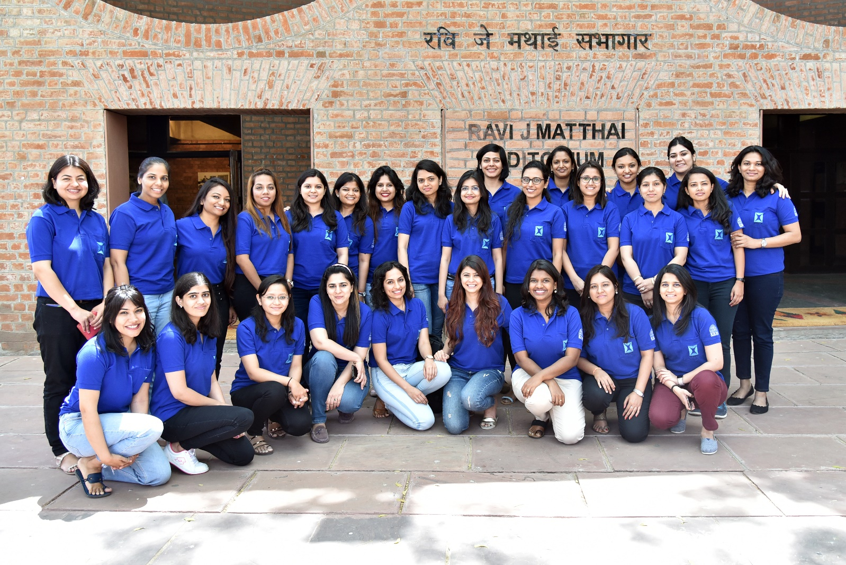

***Caption: PGPX 2019-20 Batch Inaugural day***

**April 11, 2019 | Ahmedabad**: The 14th batch of the Indian Institute of Management, Ahmedabad (IIMA)’s One-year Full time residential Post Graduate Programme in Management for Executives (PGPX) for 2019-20 was inaugurated today by Director, Prof. Errol D’Souza, and welcomed by Prof. Arindam Banerjee, Chairperson, PGPX and Prof. Shailesh Gandhi, Dean - Programmes at RJM Auditorium, Indian Institute of Management Ahmedabad (IIMA).

*Professor Arindam Banerjee, Chairperson, PGPX said, “Diversity in the student population helps in enriching the learning process by bringing in diverse perspectives in the class-room discussion. It appears we are on the right track in terms of work experience, profiles and gender diversity in our batches.”*

**Data for PGPX Programme: Female students**

|  |  |  |
| --- | --- | --- |
| **Batch** | **Percentage of**  **Female Students** | **Batch Total** |
| 2017-18 | 25% | 115 |
| 2018-19 | 17% | 138 |
| 2019-20 | 23% | 140 |

*New PGPX 19-20 batch student, Squadron Leader, IAF, Ms. Shally Aggarwal (Retd.) said, “From the onset of my MBA journey, I looked for the program that can offer an excellent classroom learning experience to intense work experience individuals like me. For me, PGPX out shined other comparable programmes because of the rich diversity of the cohort it offered - in the terms of industry, roles, geography, cultures and so on that forms the basis of an unparalleled exposure and peer to peer learning.”*

Other than the rise in gender diversity, the current batch is also very diverse in terms of work-experience (21 industries, innumerable functional areas, and 140 companies), NRIs (9.29% are residing outside India, spread across 6 countries) and international work-experience (35% of the batch has worked abroad before joining PGPX).

Launched in 2006, more than 1000 students have graduated from PGPX so far. ​Till 2016-17, the PGPX intake was 90 and from 2017-18, the institute added one more section to enhance learning experience of participants. ​With the overwhelming response, we have continued the extra section and accordingly, 140 students have been admitted this year.

The 2019-20 batch has an average GMAT score of around 702 and GRE score of 320, average age of around 32 years, average total work experience of 8.9 years, and average international experience of approximately a year and half. ​ ​

- The End -

**About Indian Institute of Management Ahmedabad (IIMA)**

Established in 1961, the Indian Institute of Management, Ahmedabad (IIMA) is recognized globally for excellence in management education. One of the top management schools in the world, IIMA educates leaders of the enterprises. The Institute’s strategic priorities include: strengthening connection with its various constituencies, including academics, practitioners, alumni, and the community; nurturing a high-performance work environment of stretch, autonomy, and teamwork; and strategic growth while maintaining emphasis on quality.

The flagship Post Graduate Programme (PGP) is ranked 21st in the Financial Times Masters in Management Ranking 2017. As per the Financial Times’ Global MBA Ranking 2017, IIMA’s Post Graduate Programme for Executives (PGPX) is ranked 29th in the World. The postgraduate program in food and Agri-Business (PGP-FABM) is ranked 1st in the Eduniversal Masters Ranking 2018. IIMA has been ranked as #1 Management institute as per the National Institutional Ranking Framework (NIRF) rankings of Ministry of Human Resource Development, Government of India.

**IIMA Media Contacts**

|  |  |
| --- | --- |
| **Mr. Deepak Bhatt**  Manager, Communications  Email: [mngr-comm@iima.ac.in](mailto:mngr-comm@iima.ac.in) Phone: +91-79-66324683 | **Ms. Mitaaly Naidu**  PR Executive, Communications  Email: [pr@iima.ac.in](mailto:pr@iima.ac.in) Phone: +91-79-66324684 |