

**PRESS RELEASE**

**Handing over and the launch of marriage portal for HIV patients**

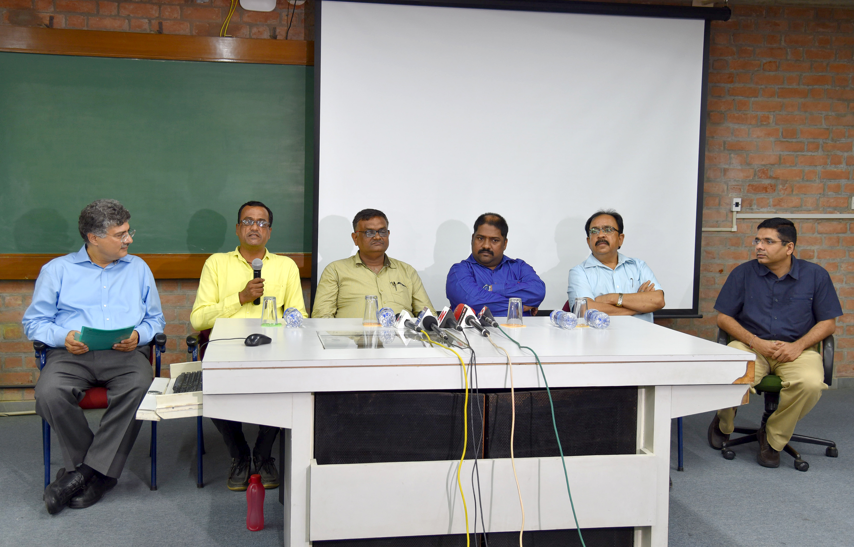

**At the launch: (l-r) Prof. Ashish Nanda, Director, IIMA; Mr. Rajbha, Member, GSNP+; Mr. Rasik Bhuva, President, GSNP+; Mr. Rajesh Kalavadiya, Sr. M&E Officer, GSNP+; Mr. Hemant Shukla, Joint Director – IEC, Gujarat State AIDS Control Programme and Prof. Rajesh Chandwani, Chairperson, CMHS, IIMA**

**August 29, 2017** **| Ahmedabad:** With effective and advanced treatment available for HIV, the longevity of the PLHIV (People Living with HIV has improved considerably over past few years. This has significant socio-cultural implications; for example, challenges related to marriage and child birth in the context of PLHIV. A team of researchers led by faculty of Centre for Management of Health Services (CMHS) at IIMA have been working on a project with GSNP+ (Gujarat State Network of Positive People): “Development of a web based portal to facilitate marriage amongst PLHIV in Gujarat.” The model, once piloted, can be then scaled across India.

*Prof. Ashish Nanda, Director, IIMA said, “I wish the PLHIV marriage portal project success. It will have a positive impact on the lives of individuals living with HIV, as also on the communities within which they live. I am proud of the work done by Professor Chandwani and other colleagues in our Center for Management of Health Services towards development of the portal. This project demonstrates the direct impact on society of some of the work being done at IIMA.”*

The website development phase is completed and will be handed over to GSNP+ for launch and management. At present, GSNP+ maintains a file of PLHIV seeking marriage. With about 500 registrations, the scope of the initiative is limited. The web based initiative will enable scaling up of registrations across the state. The design of the platform was finalized after extensive deliberations on the socio-cultural issues related to PLHIV. The team adopted a co-design process, involving all the relevant stakeholders in the design process.

*“We hope that the platform will help overcome a major social challenge related to the PLHIV in India. We are working further with GSNP+ to support other initiatives, such as, increasing PLHIVs’ adherence to treatment protocol” said, Prof. Rajesh Chandwani, Chairperson (Centre for Management of Health Services).*

*Ms. Daxa Patel, Founder member and formal Secretary, Gujarat State Network of people Living with HIV- GSNP+ said, “Being HIV positive person I know how it’s difficult to disclose HIV status and find a companion of life. We have designed this website with the needs of PLHIV in mind, which will help make the registration process easier. Marriage bureau is one of the ways to contribute to the society for positive prevention through PLHIV as well as to encourage positive living. It will enable the PLHIV in enjoying life with a life partner, where they easily disclose, care for each other, act as support system, etc. We at PLHIV community, convey our hearty gratefulness to CMHS volunteers to help us make our dreams come true.”*

**- End of Text**

***Web link of Centre for Management of Health Services (CMHS):*** [***https://www.iima.ac.in/web/areas-and-centres/research-centers/cmhs***](https://www.iima.ac.in/web/areas-and-centres/research-centers/cmhs)

**For media queries, please contact:**

**Deepak Bhatt, Manager, Communications**

Phone: (Cell) +91-9426229429, (O) +91-79-66324683, Email: [mngr-comm@iima.ac.in](mailto:mngr-comm@iima.ac.in)

**Mitaaly Naidu, Executive, Public Relations**

Phone: (Cell) +91-7069074816, (O) +91-79-66324684, Email: [pr@iima.ac.in](mailto:pr@iima.ac.in)