

**PRESS RELEASE**

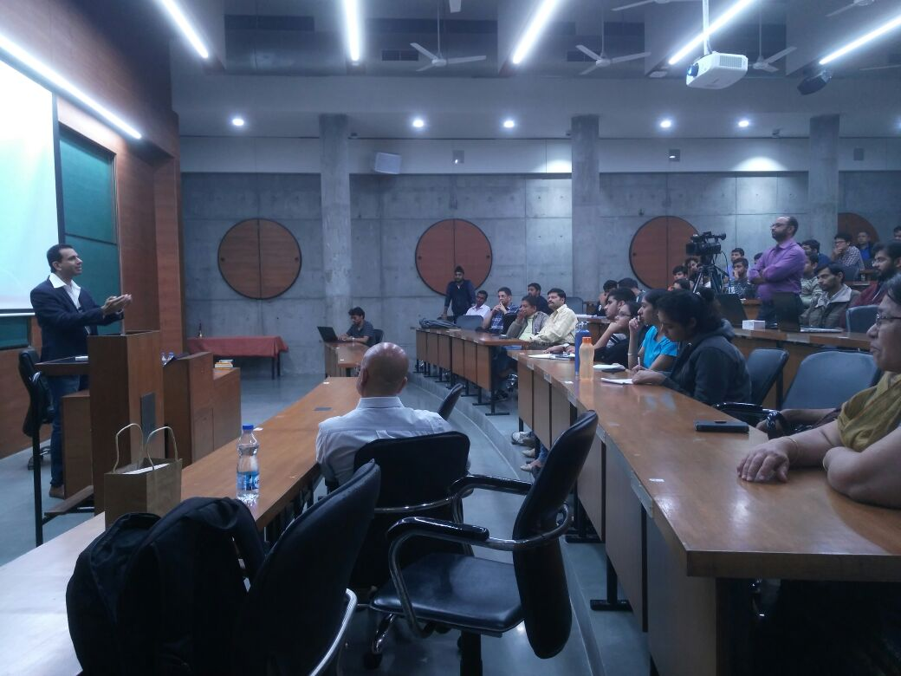**Ravi Wazir at IIMA**

***Ravi Wazir addressing the gathering at PP Gupta Auditorium, IIMA***

**January 15, 2018 | Ahmedabad**

The seventh installment of the How to Start a Startup 2.0 series – “The Secret Sauce of the Food Business”, was an exotic treat for all the food entrepreneurs with Mr. Ravi Wazir, CEO and Founder of Phoenix Hospitality Solution, an organization which provides consulting services to entrepreneurs in the hospitality, restaurant and food retail industries, addressing a young and packed audience at IIM Ahmedabad. Mr. Ravi Wazir has worn several hats- entrepreneur, consultant and professional over his unconventional career. He serves as a full-time business head in some assignments with hands-on execution, P&L, and operational responsibility as well as short-term advisory consultancy in others, consistently driving innovation and strengthening growth & sustainability capabilities of diverse ventures. His book, "Restaurant Start-up: A Practical Guide" - in its 3rd edition has continued to be the definitive bible which has shaped the way Food Startups operate.

Talking about his childhood days, Mr. Ravi recalled three major factors which piqued his interest in the food industry. His parents, he says, were food lovers and he fondly remembers having at least two long conversations a day at the dining table about the food. Second, he feels that his extremely hospitable neighbors in Bandra influenced his perceptions about how the food experience becomes complete only with people. Lastly, his grandfather – an hotelier in Pahalgam whom Mr. Ravi visited every summer, played a big part in building certain values concerning this industry. The special relationship which his grandfather shared with each of his guests made him realize that a multitude of emotions exists associated with food. Despite these early influences and a predilection towards the food industry, Mr. Ravi could not pursue an entrepreneurial venture in this space until much later in his career.

Throughout his talk, Mr. Ravi stressed the importance of the guest experience in any food business. He recounted an experience during his time at Birdy’s which taught him the importance of this. He says that merely apologizing to a customer would never forge long and lasting relationships, rather understanding that a mistake was made and acting on it would make a world of difference in this industry. Speaking about his entrepreneurial venture in the catering space, Mr. Ravi feels that although he spent only three years with his venture, the amount of learning which he gathered was immense. He says, “The entrepreneurial experience may be heart-wrenching or gut-wrenching at times, but it will always be amazing.” His critical learning’s from those three years, he says, are the value and importance of time and that perception can override logic.

Speaking next specifically about the food industry, Mr. Ravi added his two cents on what he felt was most important for any business in this sector. The most important thing to focus on, he feels, are the consumer insights. *“Stick to consumer insights, and you will always point true north,” he says.* These days, a lot of entrepreneurs are basing their ideas on what would receive funding easily from a PE rather than rely on consumer insights and market gaps. This, according to Mr. Ravi is the wrong way to go about starting a venture. Once a market gap has been found, he believes that the funding will automatically pour in. He further spoke about the importance of food with integrity and traceability of food giving some examples of specific businesses he had seen and worked with.

Advising potential entrepreneurs, he said that for any project to succeed there should be a strong sense of purpose. It is also essential to stay connected with all the stakeholders according to the Wazir. Finally, the entrepreneur should invest in his body, mind, and spirit and never neglect it. Sharing the secret formula to success in the Hospitality sector*, Ravi Wazir quotes, “A clean plan + effective execution + flexibility to adapt for enhanced customer delight + collaboration of stakeholders + good timing + luck.”*

The session 'The Secret Sauce of The Food Business', was a sector sweep for the Hospitality Industry, where the discussion touched upon a typical startup journey, why one should choose to work in this domain, what can help succeed, the current trends, enablers, and opportunities in hospitality startups and what lies ahead. The most memorable advice Mr. Wazir gave to the students was to never follow the money. They should always research where the market gaps lie, create processes and hire people that help deliver great things repeatedly.

*Shaurya Joshi, a PGP1 student, present at the session was quoted as saying, “It was a comprehensive session and he [Ravi] discussed a lot of critical aspects pertaining to the food industry for an entrepreneur.”*

-End of Text-

**About Indian Institute of Management Ahmedabad (IIMA)**

Established in 1961, the Indian Institute of Management, Ahmedabad (IIMA) is recognized globally for excellence in management education. One of the top management schools in the world, IIMA educates leaders of the enterprises.The Institute’s strategic priorities include: strengthening connection with its various constituencies, including academics, practitioners, alumni, and the community; nurturing a high performance work environment of stretch, autonomy, and teamwork; and strategic growth while maintaining emphasis on quality.

As per the latest ranking by *The Economist*, IIMA is No. 1 School in the world on the parameter of opening up new career opportunities for students. The flagship Post Graduate Programme (PGP) is ranked 16th in the *Financial Times* Masters in Management Ranking 2016. As per the *Financial Times’* Global MBA Ranking 2016, IIMA’s Post Graduate Programme for Executives (PGPX) is ranked 24th in the World. IIMA has been ranked as #1 Management institute as per the National Institutional Ranking Framework (NIRF) rankings of Ministry of Human Resource Development, Government of India.

For media queries, please contact:

|  |  |
| --- | --- |
| Gaurav Bagde  Coordinator, Entre (PGP-2)  Indian Institute of Management Ahmedabad  Ph: (Cell) +91-7506463331  Email: p16gauravb@iima.ac.in | Balaji Uppala  Media Secretary (PGP-2)  Indian Institute of Management Ahmedabad  Ph: (Cell) +91-7042705642  Email: p16srimukhab@iima.ac.in |