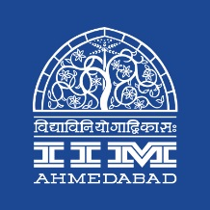

Press Release

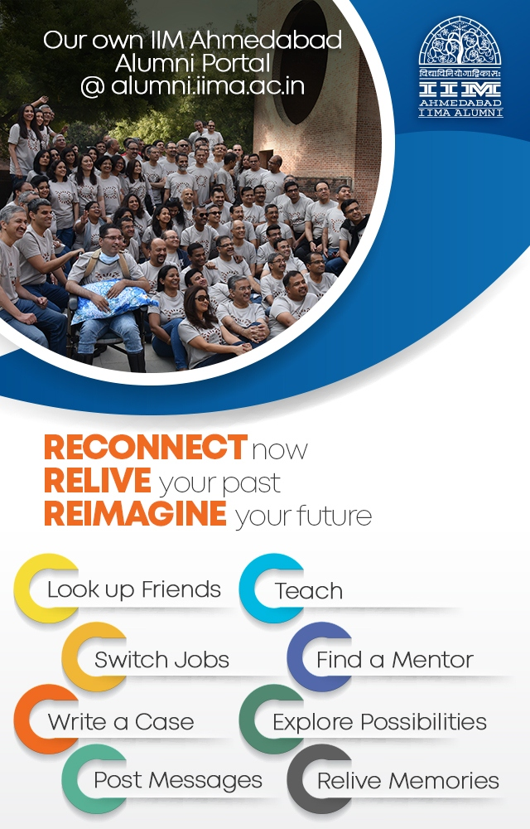**Launch of IIMA Alumni Web Portal**

**March 23, 2018 | Ahmedabad**

The Indian Institute of Management Ahmedabad launched the IIMA Alumni Portal on March 23, 2018, during the Farewell ceremony of the batch of 2018. The ceremony recognizes and awards the top achievers of the batch and is an important occasion to share information with the students on the cusp of graduating and becoming alumni.

*Prof. Errol D’Souza, Director, IIMA said,* <https://www.youtube.com/watch?v=CwAve0LBl30&feature=youtu.be>

IIMA has partnered with AlmaConnect to develop the Alumni Portal and provide a powerful platform for its alumni to connect with each other. The portal will allow alumni to look up friends, get connected to others across industries, form special interest groups, stay abreast of happenings at the institute, and leverage the network to further their professional and personal interests.

*Prof. Rakesh Basant, Dean (A&ER), IIMA said,* <https://www.youtube.com/watch?v=78_lNMWd-ok>

Seamless connectivity through social media accounts will allow alums to get aboard easily and stay updated. The portal will unlock the network potential of this valuable resource.

* The End –

**About Indian Institute of Management Ahmedabad (IIMA)**

Established in 1961, the Indian Institute of Management, Ahmedabad (IIMA) is recognized globally for excellence in management education. One of the top management schools in the world, IIMA educates leaders of the enterprises.

The Institute’s strategic priorities include: strengthening connection with its various constituencies, including academics, practitioners, alumni, and the community; nurturing a high performance work environment of stretch, autonomy, and teamwork; and strategic growth while maintaining emphasis on quality.

As per the latest ranking by The Economist, IIMA is No. 1 School in the world on the parameter of opening up new career opportunities for students. The flagship Post Graduate Programme (PGP) is ranked 21st in the Financial Times Masters in Management Ranking 2017. As per the Financial Times’ Global MBA Ranking 2018, IIMA’s Post Graduate Programme for Executives (PGPX) is ranked 31st in the World. IIMA has been ranked as #1 Management institute as per the National Institutional Ranking Framework (NIRF) rankings of Ministry of Human Resource Development, Government of India.

**For media queries, please contact:**

Deepak Bhatt

Manager, Communications

Ph: (Cell) +91-9426229429, (O) +91-79-66324683

Email: [mngr-comm@iima.ac.in](mailto:mngr-comm@iima.ac.in)

Mitaaly Naidu

Executive, Public Relations

Ph: (Cell) +91-7069074816, (O) +91-79-66324684

Email: [pr@iima.ac.in](mailto:pr@iima.ac.in)