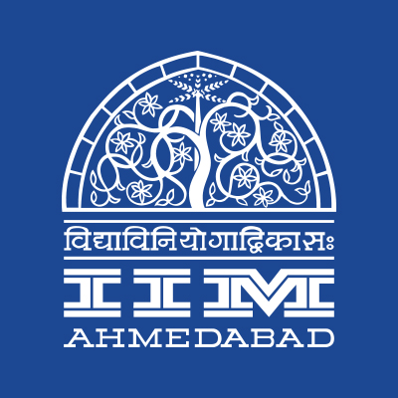

**PRESS RELEASE**

**Roopa Kudva at IIMA**

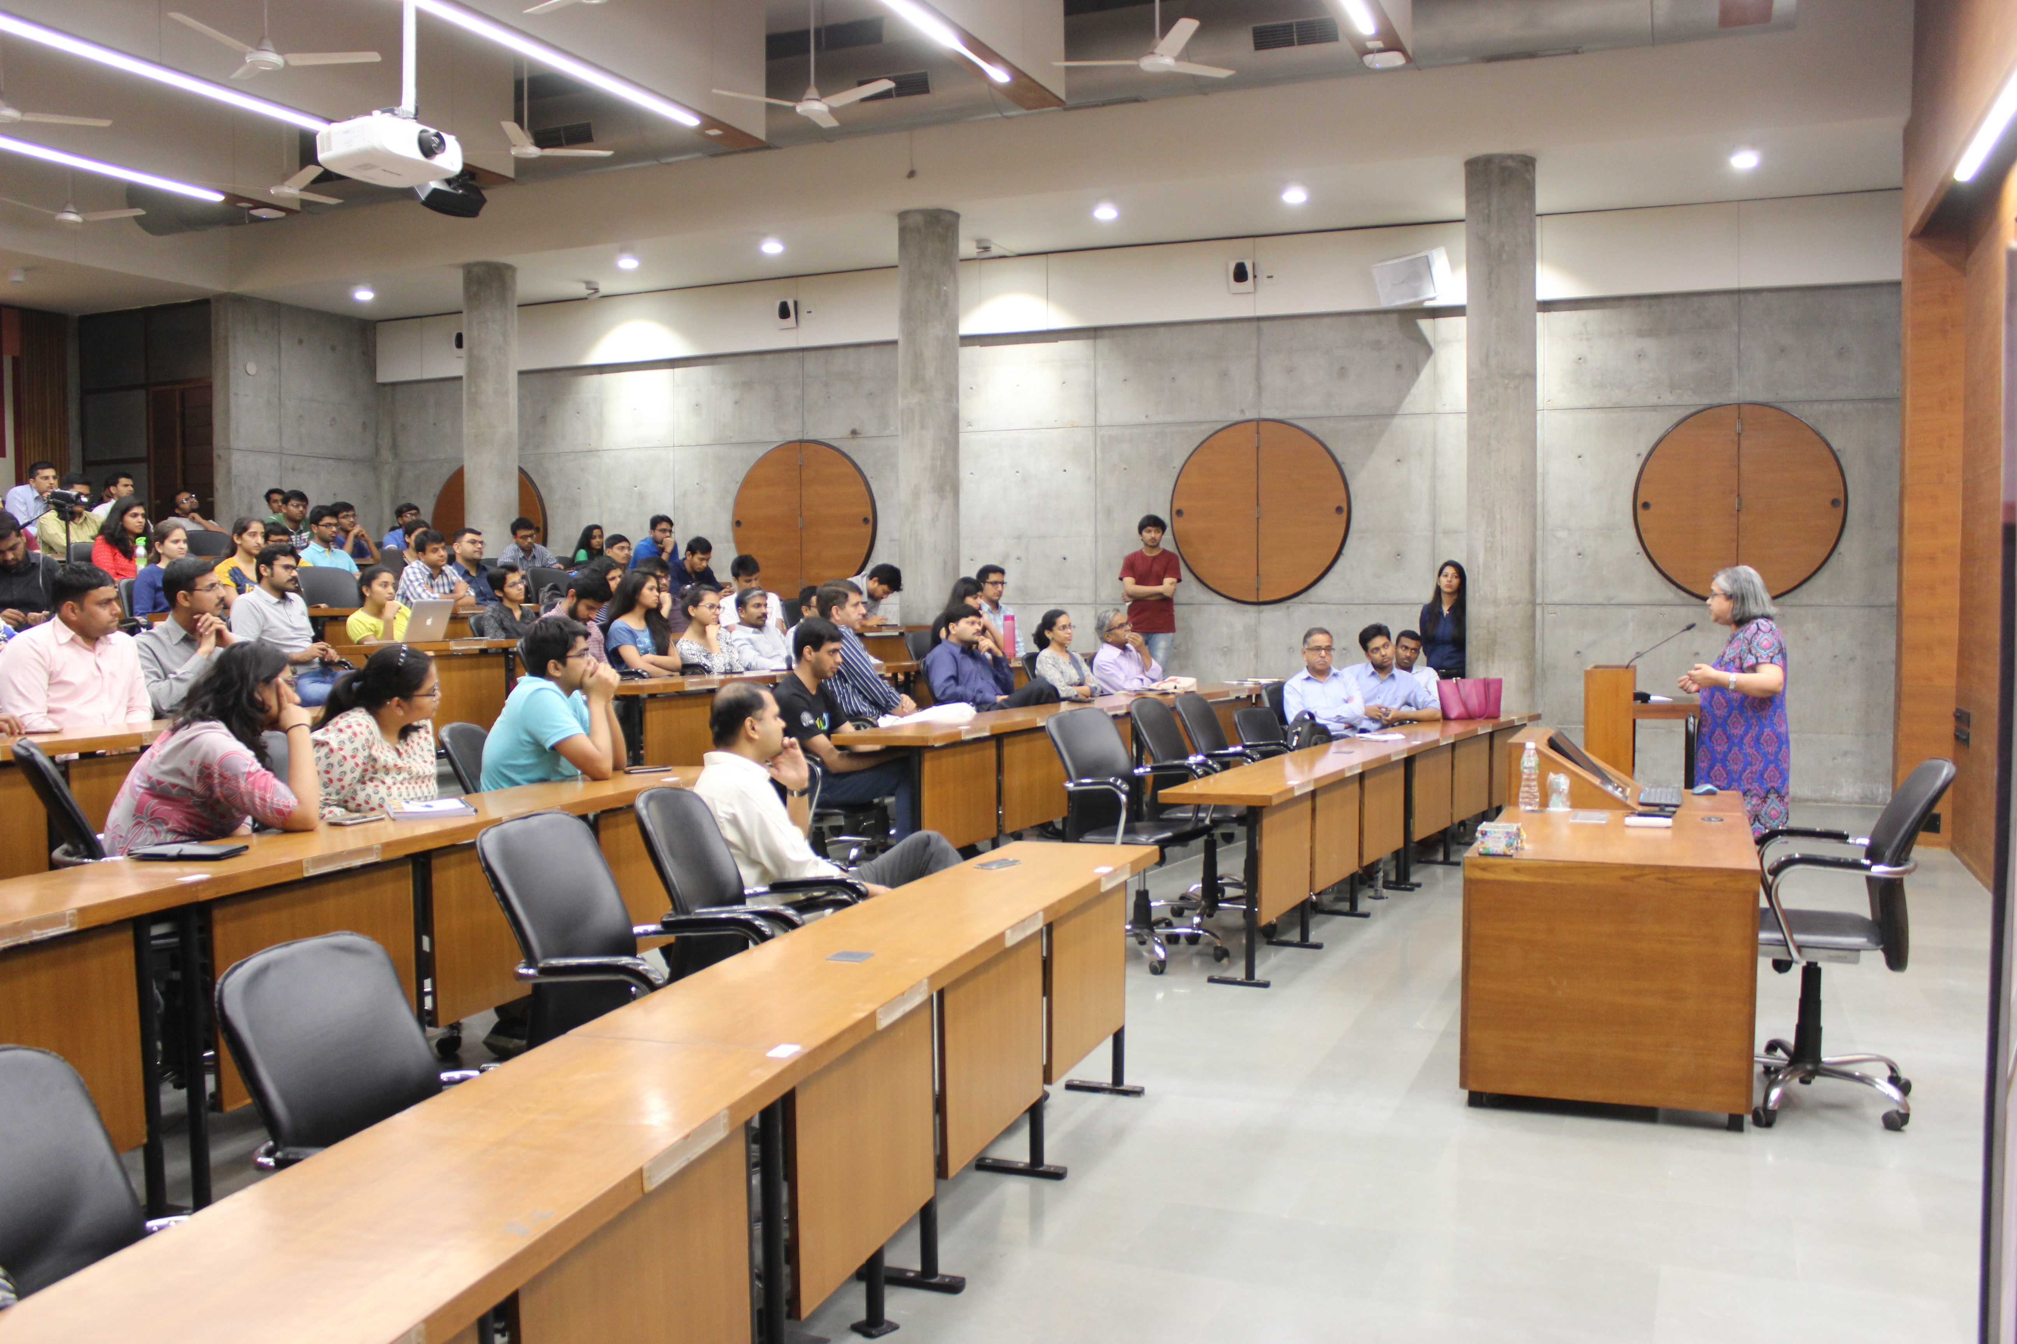

**March 5, 2018 | Ahmedabad**

Alumni & External Relations Students’ Committee (AERC) of Indian Institute of Management Ahmedabad hosted the 2nd session of its year-long speaker series - “The IIMA Inspire Series” on February 28, 2018. This session saw the esteemed Ms. Roopa Kudva, the Managing Director of the Omidyar Network India delivers a talk on innovating for the “Next Half-a-Billion” (NHB).

NHB refers to the 500 million first-time internet users expected to come online via their mobile phones, over the next five years. Highlighting the fact that this population segment has largely been excluded, underserved and disempowered until now, Ms. Kudva articulated the need for purpose-driven innovators to build businesses that create opportunities to improve their lives.

Ms. Kudva mentioned the barriers that the NHB face in their digital journey such as the lack of confidence to transact online, User interfaces not adapted to the NHB’s social/cultural context and the reticence in using the internet by women. She underlined the need for innovators looking to cater to this populace to address these barriers.

Over 40 students and members of the IIM A community attended the talk. Ms. Alina Almeida, a PGP student and coordinator of the Women Leadership Society at IIM A said *“Ms. Roopa Kudva’s speech on “Innovating for the next half billion” gave us interesting insights into how businesses today are venturing into and remodeling themselves to cater to the previously unserved bottom of the pyramid segment.”.*

For more info, please visit IIMA’s Facebook page: https://www.facebook.com/IIMAOfficial/

-End of Text-

**About Indian Institute of Management Ahmedabad (IIMA)**

Established in 1961, the Indian Institute of Management, Ahmedabad (IIMA) is recognized globally for excellence in management education. One of the top management schools in the world, IIMA educates leaders of the enterprises.The Institute’s strategic priorities include: strengthening connection with its various constituencies, including academics, practitioners, alumni, and the community; nurturing a high performance work environment of stretch, autonomy, and teamwork; and strategic growth while maintaining emphasis on quality.

As per the latest ranking by *The Economist*, IIMA is No. 1 School in the world on the parameter of opening up new career opportunities for students. The flagship Post Graduate Programme (PGP) is ranked 16th in the *Financial Times* Masters in Management Ranking 2016. As per the *Financial Times’* Global MBA Ranking 2016, IIMA’s Post Graduate Programme for Executives (PGPX) is ranked 24th in the World. IIMA has been ranked as #1 Management institute as per the National Institutional Ranking Framework (NIRF) rankings of Ministry of Human Resource Development, Government of India.

For media queries, please contact:

|  |  |
| --- | --- |
| V. Raghuram  Media Secretary (PGP-1)  Indian Institute of Management Ahmedabad  Ph: (Cell) +91- 9800172995  Email: p17vraghuram@iima.ac.in | Mithila Hegde  External Relations, Media Cell (PGP-1)  Indian Institute of Management Ahmedabad  Ph: (Cell) +91-9740499011  Email: p17mithilah@iima.ac.in |