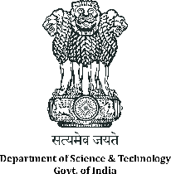 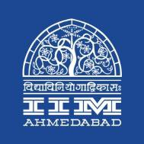 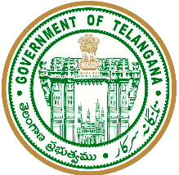

**Press Release**

**Interaction Meeting with IIM Ahmedabad and Govt. of Telangana on Peer to Peer (P2P) Energy Trading platform to highlight the benefits of Blockchain technology for Energy sector**

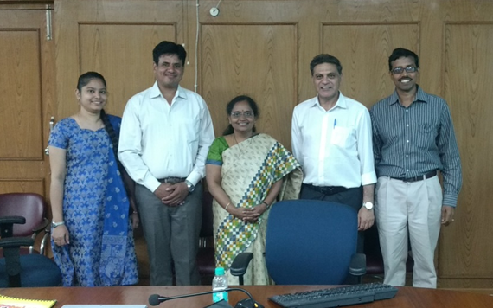

Representatives from DST, Government of Telangana and IIM Ahmedabad attending the meeting

**July 23, 2019 | Ahmedabad**

Department of Science and Technology had awarded a project on creating a Blockchain based platform for enabling Peer to Peer electricity trading to an academia-industry consortium led by IIM Ahmedabad, under the Smart Grids innovation challenge of the Mission Innovation (MI) initiative. Mission Innovation is a global initiative of  [24 countries and the European Commission](http://mission-innovation.net/our-members/) to reinvigorate and accelerate global clean energy innovation with the objective to make clean energy widely affordable.

The project aims to increase transparency and efficiency in transactions in the power sector through application of Blockchain concept in power trading at consumer levels. This assumes special significance due to large amount of distributed renewable power generation systems being implemented as a national policy by the Government of India. The Blockchain use cases are being developed in consultation with industry and academic partners.

Department of Science & Technology, GOI has organized an interaction meeting, attended by officials from ITE&C Dept, Govt. of Telangana, and principal investigator for the project from IIM Ahmedabad.

The Govt of Telangana has a Blockchain District Initiative wherein such projects are promoted, incubated and nurtured across various sectors. The Govt of Telangana and IIMA would collaborate in developing the blockchain platform for Peer to Peer Energy Trading and deploy the pilot solution in Telangana. The collaboration would further enhance the possibilities of demonstrating successful use cases for Blockchain Technology in the power sector.

* **The End –**

**About Indian Institute of Management Ahmedabad (IIMA)**

Established in 1961, the Indian Institute of Management, Ahmedabad (IIMA) is recognized globally for excellence in management education. One of the top management schools in the world, IIMA educates leaders of the enterprises. The Institute’s strategic priorities include: strengthening connection with its various constituencies, including academics, practitioners, alumni, and the community; nurturing a high-performance work environment of stretch, autonomy, and teamwork; and strategic growth while maintaining emphasis on quality.

The flagship Post Graduate Programme (PGP) is ranked 21st in the Financial Times Masters in Management Ranking 2017. As per the Financial Times’ Global MBA Ranking 2017, IIMA’s Post Graduate Programme for Executives (PGPX) is ranked 29th in the World. The postgraduate program in food and Agri-Business (PGP-FABM) is ranked 1st in the Eduniversal Masters Ranking 2019. IIMA has been ranked as #1 Management institute as per the National Institutional Ranking Framework (NIRF) rankings of Ministry of Human Resource Development, Government of India.

**For media queries, please contact:**

**Deepak Bhatt, Manager, Communication**

Ph: (Cell) +91-9426229429, (O) +91-79-66324683, Email: [mngr-comm@iima.ac.in](mailto:mngr-comm@iima.ac.in)

**Mitaaly Naidu, Executive, Public Relations**

Ph: (Cell) +91-7069074816, (O) +91-79-66324684, Email: [pr@iima.ac.in](mailto:pr@iima.ac.in)