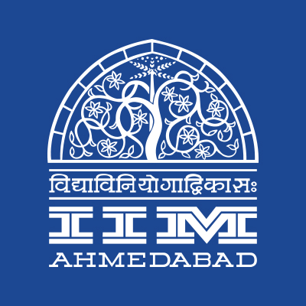

**PRESS RELEASE**

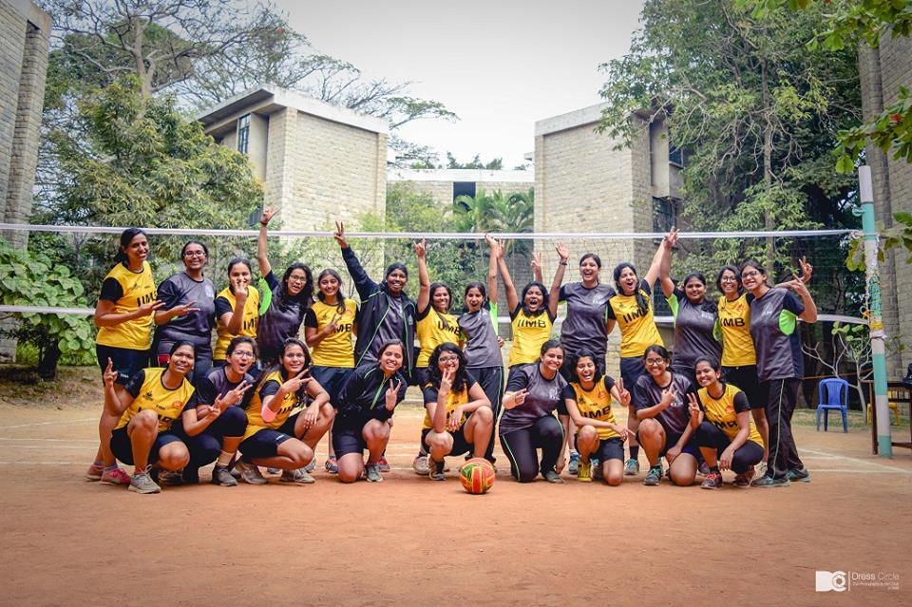**IIMA adjudged joint Runners-up at Sangharsh**

***The Women’s volleyball teams of IIMA and IIMB at the conclusion of finals match***

*Photo Courtesy: Dress Circle, IIM Bangalore*

**January 10, 2018 | Ahmedabad**

Students of the Indian Institute of Management, Ahmedabad, Bangalore, Calcutta and Lucknow (IIMA, IIMB, IIMC, IIML) have come together to celebrate sportsmanship, enthusiasm, and fitness through an Inter-IIM sports meet, **Sangharsh** held at Indian Institute of Management Bangalore from 5th to 7th January 2018. The Sports Meet boasted of enthusiastic participation from IIMA, IIMB, IIMC, and IIML. Sangharsh witnessed a host of exciting sporting events to offer to the student community-Badminton, Basketball, Football, Swimming, Table Tennis, Lawn Tennis, Cricket and many more. There were a total of 21 medal sports and five non-medal events.

The 12th edition of Sangharsh was inaugurated by Mr. Anshul Kothari, an Indian National Swimmer, as the Chief Guest on January 5, 2018. He has successfully been a part of the teams representing India at the Commonwealth Games 2010, Asian Games 2010 & 2014. He has also received Gold medals along with his team in Asian Age Group Championships 2011 and 2015. Professor G. Raghuram, Director, IIM-B; Prof. Padmini Srinivasan, PGP Chairperson, IIM-B and Prof. M S Narasimhan, Dean Admissions, IIM-B also addressed the participants of Sports meet at this occasion.

The IIMA contingent won a joint second position in the Sports Meet by scoring a total of 111 points inclusive of 3 Gold medals, 8 Silver medals, and 5 Bronze medals. The contingent was fairly represented by both male and female sports players. *Om Naik, a PGP1 participant from IIMA, was quoted as describing the event as, “Electric Atmosphere. The passion, the energy & the enthusiasm were amazing.” Harsh Kumar Singh, a Cricket Player representing IIMA, was quoted as saying, “The accommodation and Sports facilities at IIMB were excellent, and the Meet was well organized.” Another Squash player, Aayush Agrawal, vowed by saying, “I will surely incorporate Sports as a part of my daily schedule besides studying. These events make you realize how important it is for your body to be fit and active at all times, regardless of however busy your schedule might be.”*

The final standings in the competition are captured below.

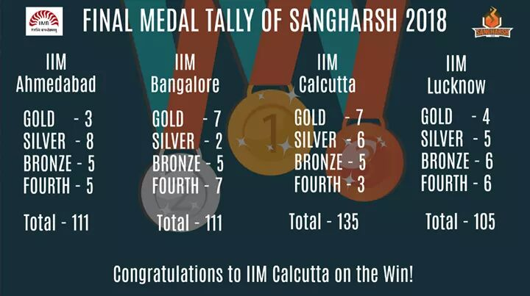

-End of Text-

**About Indian Institute of Management Ahmedabad (IIMA)**

Established in 1961, the Indian Institute of Management, Ahmedabad (IIMA) is recognized globally for excellence in management education. One of the top management schools in the world, IIMA educates leaders of the enterprises.The Institute’s strategic priorities include: strengthening connection with its various constituencies, including academics, practitioners, alumni, and the community; nurturing a high performance work environment of stretch, autonomy, and teamwork; and strategic growth while maintaining emphasis on quality.

As per the latest ranking by *The Economist*, IIMA is No. 1 School in the world on the parameter of opening up new career opportunities for students. The flagship Post Graduate Programme (PGP) is ranked 16th in the *Financial Times* Masters in Management Ranking 2016. As per the *Financial Times’* Global MBA Ranking 2016, IIMA’s Post Graduate Programme for Executives (PGPX) is ranked 24th in the World. IIMA has been ranked as #1 Management institute as per the National Institutional Ranking Framework (NIRF) rankings of Ministry of Human Resource Development, Government of India.

For media queries, please contact:

|  |  |
| --- | --- |
| Moksha  External Media Relations (PGP-1)  Indian Institute of Management Ahmedabad  Ph: (Cell) +91-8607917328  Email: a17moksha@iima.ac.in | Sameer Prakash Uppada  Sports Secretary (PGP-2)  Indian Institute of Management Ahmedabad  Ph: (Cell) +91-9490991339  Email: a16sameeru@iima.ac.in |